 Asthma Policy
June 2025

Aims:

• All staff, teaching and support staff are aware of the condition and know what to do in the event of an asthma attack

• Annual training is provided by the school nurse for all staff

• All children with asthma have easy, and immediate access to their reliever inhaler

treatment

• Records are kept of the children with asthma and regularly updated

• There is good communication between home, school and the nursing team

Asthma Champion/Asthma Lead | Justine Callaghan – The Asthma Lead can be contacted at the following email address:  jcallaghan@anson.brent.sch.uk Or on 020 8452 8552
Anson Welfare Team | Justine Callaghan  Suzanne Richards - can be contacted at the following email address:  admin@anson.brent.sch.uk or on 020 8452 8552
School Nurse | Juliet Lovell  juliet.lovell@nhs.net  07760743234
Date Approved: | June 2025
Review Date | June 2026

At Anson, we recognise that asthma is a serious, but controllable condition. The school welcomes all children with asthma and aims to support these children in participating fully in everyday school life. Anson will take on a whole school approach to asthma to support the children. We aim to actively involve parents/carers and their children in the management of asthma within school. We endeavour to do this by ensuring we have:

• an asthma register
• an asthma policy
• an asthma lead
• all pupils have immediate access to their reliever inhaler at all times
• all pupils have an asthma care plan
• an emergency salbutamol inhaler and spacer
• ensure all staff have regular asthma training
• promote asthma awareness to pupils, parents and staff

This policy has been developed within the North-West London Health and Care Partnership following National guidelines for the management of children/ young people (CYP) with asthma.

Aims
- All staff, teaching and support staff are aware of the condition and know what to do in the event of an asthma attack
- Annual training is provided by the school nurse for all staff
- All children with asthma have easy, and immediate access to their reliever inhaler treatment
- Records are kept of the children with asthma and regularly updated
- There is good communication between home, school and the nursing team

Asthma Register

During admission, parents are asked if their child has been identified as suffering with asthma or has been prescribed an inhaler for any reason.

If a child has been issued with an inhaler, parents are asked to provide a care plan, stating the correct procedure for administration, signed and stamped by a medical professional. A consent form to administer emergency an emergency inhaler will also need to be signed alongside the School Asthma Care Plan.

This information is entered onto the Anson Medical Tracker and an up-to-date asthma register is generated.

Parents of children with asthma are asked to keep the school informed of any changes in condition, or other illnesses/allergies likely to affect their asthma. This will be updated on Medical Tracker and shared with the class teacher.

Asthma Lead

Anson has an asthma lead who is named above. It is the responsibility of the asthma lead to:

• manage the asthma register
• update the asthma policy
• manage the emergency salbutamol inhalers and spacers (Dining Hall and Office)
• ensure measures are in place so that children have immediate access to their inhaler
• ensure staff training and knowledge of asthma proceedures
• promote asthma awareness with pupils and parents

Administering Inhalers

Children MUST HAVE one blue salbutamol inhaler (reliever inhaler) and one plastic spacer prescribed by their GP in school. These must have a prescription label detailing the child’s name. It is the parent’s responsibility to supply this blue inhaler and spacer to the school. This is kept in the class medical box. All inhalers will be easily and immediately accessible and never locked away. All classrooms are equipped with a class medical box. This will contain each child’s individual labelled medication and spacer.

If a child needs their inhaler, a staff member MUST observe that they are following the correct procedure (if using independently) or administer the medication for them. In the event of an asthma attack, a staff member MUST retrieve the correct inhaler from the classroom and the child should remain where they are, under the supervision of another adult.

All inhaler usage will be recorded on Medical Tracker and the parents informed by email. The welfare team will monitor inhaler use and liaise with the parents and School Nurse if any children are needing to use their inhaler on a regular basis (weekly or more frequently)

Preventative inhalers are NOT needed in school. They should be administered at home before and after school. Any preventative medication will be sent home if brought into school.

Access to Inhalers

Children with asthma will have access to their inhaler whenever needed with supervision and support from an adult.

PE and Sports Clubs

All staff will know which children in their class have asthma and PE teachers will be informed by the teacher of any children on the asthma register. PE teachers will remind pupils whose asthma is triggered by exercise to take their reliever inhaler and spacer before the lesson. It is agreed with PE staff that pupils who are mature enough will carry their inhaler and spacer with them and those that are too young will have their inhaler labelled and kept at the site of the lesson. If a pupil needs to use their inhaler during PE lesson they will be encouraged to do so.

Sport Coaches at the school will be aware of which pupils have asthma as these will be highlighted on their club registers or on the school asthma register.

It is essential that the teacher ensures their class’s asthma medication is taken with the class on all school trips, swimming etc.

Emergency Asthma Kits

The school has emergency asthma kits which are held in the school office and dining hall. The emergency inhaler/spacer should only be used in an emergency if the child’s own inhaler / spacer is not available (expired / empty / lost). The spacer is to be washed in warm soapy water and left to air dry and the inhaler should be wiped clean with an anti-bacterial wipe after use.

We will ensure that the emergency salbutamol inhaler is only used by children who have been diagnosed with asthma OR who have been prescribed a reliever inhaler AND for whom written parental consent for use of emergency inhaler has been given.
Each pack will contain:
- 1 blue Salbutamol inhaler
- 1 plastic spacer
- an emergency asthma plan poster
- register of consented asthmatic children
- record of administration

We understand that salbutamol is a relatively safe medicine, particularly if inhaled, but all medicines can have some adverse effects. Those of inhaled salbutamol tend to be mild and temporary and are not likely to cause serious harm. The child may feel a bit shaky or may tremble, or they may say that they feel their heart is beating faster.

It is the Welfare Team’s job to ensure the class and emergency boxes are regularly checked and contain all the agreed equipment.

Common ‘Day to Day’ Symptoms of Asthma

As a school we require that children with asthma have a personal asthma care plan which can be provided by their doctor / nurse. These plans inform us of the day-to-day symptoms of each child’s asthma and how to respond to them in an individual basis. The most common day-to-day symptoms of asthma are:
• Dry cough
• Wheeze (a ‘whistle’ heard on breathing out) often when exercising
• Shortness of breath when exposed to a trigger or exercising
• Tight chest

These symptoms are usually responsive to the use of the child’s inhaler and rest (e.g. stopping exercise). As per Department of Health Guidance, they would not usually require the child to be sent home from school or to need urgent medical attention.

Asthma Attack

In the case of an asthma attack the teacher should follow the instructions on the asthma attack poster situated in all classrooms and keep the child calm. PLEASE TREAT CHILD WHERE THEY ARE AND SEND FOR HELP IMMEDIATELY.

The Department of Health Guidance on the use of emergency salbutamol inhalers in schools (March 2015) states the signs of an asthma attack are:

• Persistent cough (when at rest)
• A wheezing sound coming from the chest (when at rest)
• Difficulty breathing (the child could be breathing fast and with effort, using all accessory muscles in the upper body).
• Nasal flaring.
• Unable to talk or complete sentences. Some children will go very quiet
• May try to tell you that their chest ‘feels tight’ (younger children may express this as tummy ache)

If the child is showing these symptoms, we will follow the guidance for responding to an asthma attack recorded below:
• Keep calm and reassure the child
• Encourage the child to sit up and slightly forward
• Use the child’s own inhaler – if not available, use the emergency inhaler
• Remain with the child while the inhaler and spacer are brought to them
• Shake the inhaler and remove the cap
• Place the mask securely over the nose and mouth
• Help the child to take two puffs of salbutamol via the spacer, one at a time. (r 1 puff to 5 breaths or 20 seconds per dose with mask)
• If there is no improvement, repeat these steps* up to a maximum of 10 puffs
• If you have had to treat a child for an asthma attack in school, it is important that we inform the parents/carers and advise that they should make an appointment with the GP
• If the child has had to use 6 puffs or more in 4 hours the parents should be made aware and they should be seen by their doctor/nurse.

If the child does not feel better or you are worried at ANYTIME before you have reached 10 puffs, call 999 FOR AN AMBULANCE and call for parents/carers.

• If an ambulance does not arrive in 10 minutes give another 10 puffs in the same way
• A member of staff will always accompany a child taken to hospital by an ambulance and stay with them until a parent or carer arrives.

However, we also recognise that we need to call an ambulance immediately and commence the asthma attack procedure without delay if the child:

• Cannot speak /short sentences
• Symptoms getting worse quickly
• Appears exhausted
• Has a blue/white tinge around lips
• Has collapsed

Asthma Friendly School Status

Our school is currently an Asthma Friendly school. This status is reviewed annually by the School Nursing Team and the following criteria must be met each year for it to be awarded:

- Named Asthma Champion
- Named Asthma Lead
- Register of all children with Asthma
- Management plan for children with asthma (Asthma Care Plan)
- Asthma Champion links with Community Asthma services & attends Annual workshop
- Clear Asthma policy
- Accessible inhalers
- Annual school staff training (minimum 85% attendance required)
- Display of emergency plan posters
- Emergency inhaler kits
- Annual asthma audit

Whole School Training
In order to support the management of children’s asthma within our school, whole school staff training is to be updated annually to ensure that ALL staff are aware of the procedures to follow in the event of a child having a possible asthma attack.

Legal Position
Staff are legally covered by the LEA to administer asthma treatment. It is illegal to use with one child the inhaler of another, even in an emergency.

Our asthma policy incorporates national guidelines recommended on the management of asthma care in school. The policy is in place to maintain the safety of all children with asthma at our school and to support our school staff team in doing so.

APPENDIX 1

Symptoms of an Asthma Attack

• Not all symptoms listed have to be present for this to be an asthma attack

• Symptoms can get worse very quickly

• If in doubt, give emergency treatment.

• Side effects from salbutamol tend to be mild and temporary. These side effects include feeling shaky, or stating that the heart is beating faster.

Cough
A dry persistent cough may be a sign of an asthma attack.

Chest tightness or pain
This may be described by a child in many ways including a ‘tight chest’, ‘chest pain’, tummy ache.

Shortness of breath
A child may say that it feels like it's difficult to breathe, or that their breath has ‘gone away’.

Wheeze
A wheeze sounds like a whistling noise, usually heard when a child is breathing out. A child having an asthma attack may, or may not be wheezing.

Increased effort of breathing
This can be seen when there is sucking in between ribs or under ribs or at the base of the throat. The chest may be rising and falling fast and in younger children, the stomach may be obviously moving in and out. Nasal flaring.

Difficulty in speaking
The child may not be able to speak in full sentences.

Struggling to breathe
The child may be gasping for air or exhausted from the effort of breathing.

CALL AN AMBULANCE IMMEDIATELY, WHILST GIVING EMERGENCY TREATMENT IF THE CHILD

• Appears exhausted
• Has blue/white tinge around the lips
• Is going blue
• Has collapsed

APPENDIX 2

Administering Reliever Inhaled Therapy through a Spacer

A metered dose inhaler can be used through a spacer device. If the inhaler has not been used for 2 weeks, then press the inhaler twice into the air to clear it.

Large or small spacer:

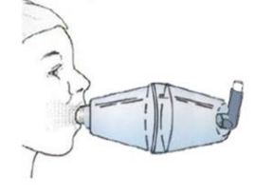

1. Keep calm and reassure the child
2. Encourage the child to sit up
3. Remove cap from inhaler
4. Shake inhaler and place it in the end of the spacer
5. Place mouthpiece in mouth with a good seal
6. Press the canister encouraging the child to continue to breathe in and out for 5 slow breaths
7. Remove the spacer.

A spacer with mask:

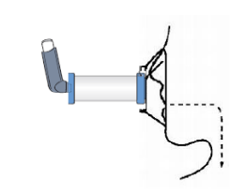

1.Keep calm and reassure the child
2. Encourage the child to sit up
3. Remove cap from inhaler
4. Shake inhaler and place it in the end of the spacer
5. Place mask over nose and mouth with a good seal, (Tipping inhaler end of the spacer up)
6. Press the canister encouraging the child to continue to breathe in and out for 20 seconds
7. Remove the spacer from the face.
8. Repeat from step 1 until the dose needed has been given.

Depending on responses, steps 2-7 can be repeated according to response up to 10 puffs.

If there is no improvement CALL 999.

If help does not arrive in 10 minutes give another 10 puffs in the same way.

If the child does not feel better or you are worried ANYTIME before you have reached 10 puffs, call 999 for an ambulance and continue to treat as above.

APPENDIX 3

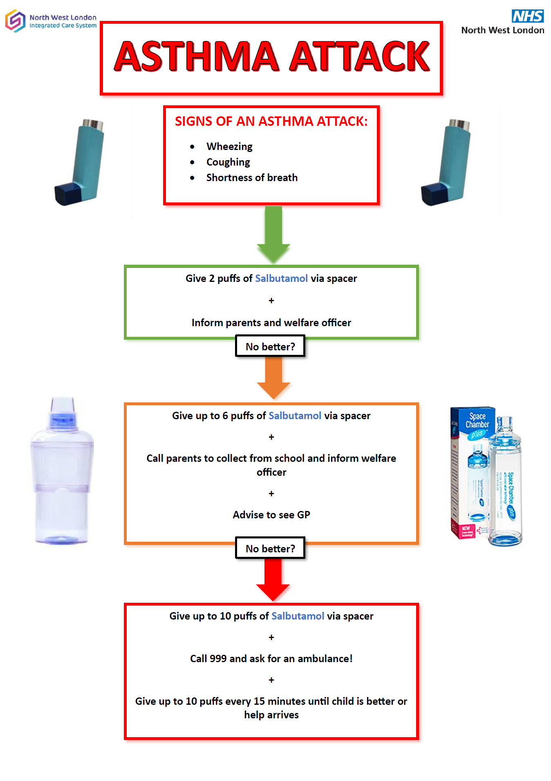

APPENDIX 4

School Asthma Care Plan

Date:

Name:………………………………………………………………….. Date of birth:……………………………………………………………

Allergies:……………………………………………………………….. Emergency contact:…………………………………………………..

Emergency contact number:…………………………………. Doctor’s phone number:…………………………………………….

Class…………………………………………………………………..
Does your child need help using their inhaler? Yes / No

Does your child need to take their reliever medicine before exercise? Yes / No
What are the signs that your child may be having an asthma attack?

Are there any key words that you/your child may use to express their asthma symptoms?

What are your/your child’s known asthma triggers?

I give my consent for school staff to administer/assist my child with their own reliever inhaler as required. Their inhaler is clearly labelled and in date.

Print Name……………………………… Signed……………………………………

Date…………………………… Relationship to child………………………………

APPENDIX 5

Consent Form

Use of Emergency Salbutamol Inhaler

Child showing symptoms of asthma/having asthma attack

1. I can confirm that my child has been diagnosed with asthma/has been prescribed an inhaler

2. My child has a working, in-date inhaler and spacer, clearly labelled with their name, that will be left at school

3. I will provide an Asthma Care Plan for my child, signed and stamped by a doctor/nurse

4. In the event of my child displaying symptoms of asthma, and if their inhaler is not available or is unusable, I consent for my child to receive salbutamol from an emergency inhaler held by the school for such emergencies

Print Name……………………………… Signed……………………………………

Date…………………………… Relationship to child………………………………

