Safeguarding And

Child Protection Policy
September 2025

Aims:
- To develop a culture of vigilance where “safeguarding is everyone’s responsibility and a part of everyday life” at Anson Primary School
- To provide all staff with the necessary information to enable them to meet their safeguarding responsibilities.
- To demonstrate the school’s commitment with regard to safeguarding of pupils, parents, carers and other partners.
- To provide a systematic means of monitoring children known or thought to be at risk of harm.
- To emphasise the need for good levels of communication between all members of staff.
- To develop a structured procedure within the school to be followed by all members of the school community in cases of suspected abuse.
- To develop and promote effective working relationships with other agencies, especially Social Services, health and the police.
- All paid and unpaid staff are given appropriate support, training and information.
- To ensure all members of the school community are treated with dignity and respect.

Designated Safeguarding Leader (DSL) | Justine Callaghan – The Designated Safeguarding Lead can be contacted at the following email address:  safeguarding@anson.brent.sch.uk Or on 020 8452 8552
Deputy Designated Safeguarding Leader (DDSL) | Elaine Barrett - The Deputy Designated Safeguarding Lead can be contacted at the following email address:  safeguarding@anson.brent.sch.uk Or on 020 8452 8552
Designated Safeguarding Officers (DSO) | Paula Lynch  Simon Pile
Digital Safeguarding Lead | Simon Pile
Designated Governor for Safeguarding | Mitchell Clarke
Last review date: | September 2024
Date Approved: | September 2024
Review Date | September 2025

Contents Page

Introduction, Safeguarding Statement & Legal Guidance 4
Terminology 5
Equality Statement 5
Procedures 5
Responsibilities (Designated Safeguarding Lead) 7
Responsibilities (Governors) 7
Child Protection & Supporting Children 8
Opportunities to teach Safeguarding 8
Extra-familial harms 9
Safeguarding and Mental Health 9
Pupils with a Social Worker 9
Online Safety 9
Types of Abuse 10
FGM - Mandatory reporting procedures 10
Child Missing in Education (CME) 13
Child on Child Sexual Abuse and Harassment 14
Other Key Safeguarding Areas 18
Looked After Children (LAC) 21
Special Guardianships & Adoption 21
Private Fostering 21
Young Carers 22
Pupils with SEND 22
Safeguarding in Early Years 23
Confidentiality 23
Supporting Staff 23
Allegations against Staff 23
Low-level Concerns 23
Whistleblowing & Whistle blowing Pathways 24
Physical Intervention 25
Outside Agency Involvement 25
Safer Recruitment 25
Disqualification by Association 25
Health & Safety 26
Accidents & Welfare 26
Intimate Care 26
Site Safeguarding 26
Fire Drills 26
Behaviour of Visitors 26
Information Sharing 26
Appendix Contents 27

INTRODUCTION
This policy aims to provide all members of staff (paid and unpaid), Governors, children and young people, and their families with a clear and secure framework for ensuring that all children at Anson Primary School are protected from harm, both while at school and when off the school’s premises e.g. when on a school visit. As part of this policy, we have assessed the risks and issues in the wider community when we are considering the wellbeing and safety of our pupils and the contents of this policy.
Anson Primary School Safeguarding statement

At Anson Primary School, we recognise our moral and statutory responsibility to safeguard and promote the welfare of all pupils. We expect everyone in our school to share this commitment. Our safeguarding culture is embedded across the school in our policies and procedures, our ethos and our curriculum. We endeavour to teach our children what it means to be safe, how to behave respectfully towards others and how to recognise if they are experiencing harm. They will know how to access support, confident that their voices will be heard and their concerns taken seriously. We are alert to the signs of abuse and neglect and follow our procedures to ensure that children receive effective support and protection. Safeguarding is everyone’s responsibility and all staff may raise concerns directly with children’s services. Anson Primary School believes in supporting all aspects of children and young people’s development and keeping them safe. We will ALWAYS act in the best interest of the child.

LEGAL GUIDANCE and POLICIES
This policy has been drawn up on the basis of law and guidance that seeks to protect children, namely:
- Keeping Children Safe in Education 2025
- Working Together to Safeguard Children, December 2023
- Meeting digital and technology standards in schools and colleges, March 2023
- Generative artificial intelligence (AI) in Education 2025
- Teacher standards
- London Child Protection Procedures
- Children Act 1989
- United Convention of the Rights of the Child 1992
- Data Protection Act 2018
- Staff Code of Conduct
- Anson Behaviour Policy and Procedures
- Anti-Bullying Policy
- Anti-Racism Policy
- Online Safety Policy
- Relationships Education Policy
- Behaviour in Schools – advice for head teachers and school staff
- Children missing education: statutory guidance for local authorities – September 2016
- Sexual Offences Act 2003
- Children Act 2004
- Protection of Freedoms Act 2012
- Information Sharing July 2018 - Information sharing Advice for practitioners providing safeguarding services to children, young people, parents and carers, DfE, 2018
- Education Act 2011
- Searching, screening and confiscation, advice for schools, September 2022
- Terrorism Act 2006
- Prevent Duty Guidance 2023

- Guidance for safer working practice for those working with children and young people in education settings February 2022
- When to call the police for schools and colleges
- Sharing Nudes and Semi-nudes: advice for education settings working with children and young people December 2020
- Child Sexual Exploitation – A guide for practitioners, February 2017

TERMINOLOGY
- Safeguarding and promoting the welfare of children is defined for the purposes of this policy as:
- protecting children from maltreatment
- preventing impairment of children’s mental and physical health or development
- ensuring that children grow up in circumstances consistent with the provision of safe and effective care
- taking action to enable all children to have the best outcomes
- Child protection refers to the processes undertaken to protect children who have been identified as suffering, or being at risk of suffering significant harm.
- Staff refers to all those working for or on behalf of the school, full time or part time, in either a paid or a voluntary capacity.
- Child refers to all young people who have not yet reached their 18th birthday.

- Parent or Carer refers to birth parents and other adults who are in a parenting role, for example stepparents, foster carers and adoptive parents or aunts, uncles or grandparents if there is a private fostering arrangement.

EQUALITY STATEMENT

We recognise that:
- The welfare of the child is paramount, as enshrined in the Children Act 1989
- All children, regardless of age, disability, gender, racial heritage, religious belief, sexual orientation or identity, have a right to equal protection from all types of harm or abuse
- Some children are additionally vulnerable because of the impact of previous experiences, their level of dependency, their special educational needs or other issues
- Working in partnership with children, young people, their parents, carers and other agencies is essential in promoting young people’s welfare

PROCEDURES
Our school procedures for safeguarding children will be in line with Local Authority and Brent Safeguarding Partnerships and should be read in conjunction with Keeping Children Safe in Education September 2024.
In order to ensure children are adequately protected, we will ensure that:
  - We have a Designated Safeguarding Lead (DSL) and a Deputy DSL (DDSL), who have passed level 3 safeguarding training and two Designated Safeguarding Officers (DSO), one of which is EYFS trained. All school staff will receive training for safeguarding to ensure they understand and adhere to ‘Keeping Children Safe in Education 2025’. In addition to this staff will take part in ongoing CPD covering a range of contextual safeguarding issues.
  - All staff have read and understand Part One of KCSIE 2025 and are aware of the indicators of child abuse and how to respond to concerns or allegations of abuse by children.

  - All staff have an understanding of the expectations, applicable roles and responsibilities in relation to filtering and monitoring.
  - The Safeguarding Policy is reviewed on an annual basis by the Head Teacher, DSL and the board of Governors unless an incident or new legislation or guidance suggests the need for an interim review.
  - The DSL/Deputy DSL will be the first people to be approached in the light of any concerns, allegations or disclosures.
  - There are two Designated Safeguarding Officers, who will act in the absence of the DSL and DDSL, who will also receive appropriate training.
  - The Designated Safeguarding Lead will meet with the safeguarding team to monitor the Child Protection record for the school to ensure it is an accurate and an up-to-date record.
  - All members of staff are familiar with the categories and definitions used when referring to Child Protection.
  - All members of staff develop their understanding of the signs and indicators of abuse. (See Appendix 3.1 – 3.9)
  - All members of staff know how to respond to a pupil who discloses abuse. They will ensure that time is given to the child in order that they can fully concentrate on the child’s disclosure and that this time is found as a matter of urgency. This information will then be passed on via the Safeguarding and Child Protection Online Monitoring System (CPOMS) or if there is no access to the online system then information will be passed on using the Safeguarding Concerns form (see Appendix 6) and by speaking to the Designated Safeguarding Lead.
  - All members of staff are aware that children may not feel ready or know how to tell someone that they are being abused, exploited, or neglected, and/or they may not recognise their experiences as harmful. For example, children may feel embarrassed, humiliated, or are being threatened. This could be due to their vulnerability, disability and/or sexual orientation or language barriers. This should not prevent staff from having a professional curiosity and speaking to the designated safeguarding lead (DSL) if they have concerns about a child. It is also important that staff determine how best to build trusted relationships with children and young people which facilitate communication.
  - All staff should be able to reassure victims that they are being taken seriously.
  - The Designated Safeguarding Leads will ensure that the correct Safeguarding and Child Protection recording systems and forms are made accessible to staff.
  - All parents/carers are made aware of the responsibilities of staff members with regard to safeguarding procedures. The Safeguarding Policy will be available on the school website with a poster of the designated safeguarding team for parent/carer reference.
  - All new members of staff will be emailed a copy of our Safeguarding Policy, Staff Code of Conduct and Keeping Children Safe in Education (September 2025) as part of their induction into the school and as updates are released.
  - Training undertaken by the Designated Safeguarding Leads and Safeguarding Officers pertaining to child protection and safer recruitment will be documented and recorded.
  - Staff will use the Child Protection Online Monitoring System CPOMS to raise concerns and add chronology about a child. Where the concern refers to Child Protection DSLs will be alerted immediately in person.
  - All staff will know will be aware of Early Help and Family Wellbeing Centres in our local area. They will understand the Early Help referral process and their role in identifying families who would benefit from Early Intervention.
Information on Family Wellbeing Centres can be found here: https://www.brent.gov.uk/children-young-people-and-families/support-for-parents-and- families/family-wellbeing-centres

  - Please see Appendix 17 for our Continuing Professional Development and training matrix for Safeguarding.

RESPONSIBILITIES – Designated Safeguarding Lead
The Designated Safeguarding Lead (DSL) is responsible for:
  - Adhering to the Brent Safeguarding Partnerships advice, Local Authority and school procedures with regard to referring a child if there are concerns about possible abuse.
  - Recording any concerns and actions on CPOMS and monitoring all year groups by completing regular audits of information.
  - Ensuring that ongoing monitoring of Vulnerable Pupils is up to date.
  - Ensuring that action points agreed at Child Protection Conferences, Child Protection Reviews and Core Group Meetings are carried out.
  - Ensuring that accurate and up to date information about individual children is presented at Child Protection Conferences.
  - Ensuring that all such records are kept confidentially and securely and are separate from pupil records.
  - Ensuring that all records are passed on to their next school.
  - Ensuring that any pupil currently with a Child Protection plan (CP) who is absent without explanation is referred to their Key Worker or Social Worker and that the attendance of children with a Child in Need Plan (CIN) or those who are ‘Vulnerable pupils’ is monitored closely and any concerns referred to their key social worker.
  - Manage referrals from school staff or any others from outside the school.
  - Work with external agencies and professionals on matters of safety and safeguarding.
  - Undertake training.
  - Raise awareness of safeguarding and child protection amongst the staff and parents.
  - Be aware of pupils who have a social worker.
  - Help promote educational outcomes by sharing the information about the welfare, safeguarding and child protection issues with teachers and school leadership staff.
  - Be aware of pupils who have a social worker and help promote educational outcomes for this vulnerable pupil group.

RESPONSIBILITIES – Governors
Members of the Governing Body of the school take part in mandatory safeguarding training to ensure that they can ‘assure themselves that the safeguarding policies and procedures in place in schools and colleges are effective.’ This training is regularly updated.

The school has a designated safeguarding governor, Mitchell Clarke, who will act as the link person between the governing body and the designated safeguarding leads. The governor will review safeguarding procedures/practices including access to training through regular meetings with the safeguarding leads. Where safeguarding concerns arise regarding a member of staff, the governor will liaise with the Head teacher and the Chair of Governors. If the concern relates to the Head teacher, the Chair of Governors will liaise with the Local Authority Designated Officer (LADO). See Appendix 14 for information provided by the LSCB for how staff allegations are managed.

‘When an Allegation is made against a member of staff (paid/unpaid) the Designated Senior Manager for Allegations (DSM) within your agency should be informed and should immediately consult the Local Authority Designated Officer (LADO)’. Brent LSCB 2019

CHILD PROTECTION & SUPPORTING CHILDREN
We recognise that the school has a role to play in supporting children who are experiencing great challenges in their lives. We also recognise that these challenges may be of a child protection nature. We acknowledge that the school may provide the only stability in the lives of children who have been abused or who are at risk of harm. We recognise that the school should fully understand how being a victim of abuse can manifest itself in numerous ways. We recognise that the school must endeavour to put in place systems and ongoing training in order that all members of staff can act appropriately. Children will always be given time and privacy to talk to a member of staff in order to discuss issues that are affecting them or worrying them. We appreciate that a child who is abused or witnesses abuse may find it difficult to develop and maintain a sense of self-worth. We understand that a child in these circumstances may feel helpless, humiliated and may feel self-blame. We accept that research shows that the behaviour of a child in these circumstances may range from that which is perceived to be normal to aggressive or withdrawn. We undertake a trauma informed approach to behaviour.

OPPORTUNITIES TO TEACH SAFEGUARDING
Children at Anson Primary School are taught about how they can keep themselves and others safe, including online. To be effective, we present this information in an age-appropriate way. We are sensitive to the specific needs and vulnerabilities of individual children, including children who are victims of abuse, and children with special educational needs or disabilities. On our school curriculum map, safeguarding is threaded through the curriculum. Our curriculum will tackle, at an age-appropriate stage, issues such as:
  - supporting children to develop the skills that form the building blocks of all positive relationships
  - healthy and respectful relationships
  - boundaries, consent and kindness in relationships
  - stereotyping, prejudice and equality
  - body confidence and self-esteem
  - how to recognise negative relationships, including peer pressure, exploitation and controlling behaviour.

We will seek to support and keep children safe by:
    - Valuing them, listening to and respecting them
    - Sharing concerns with agencies who need to know, and involving parents and children appropriately
    - Encouraging self-esteem and self-assertiveness whilst not condoning aggression or bullying – PSHE, assemblies, workshops, Golden Rules and Learning Behaviours etc.
    - Promoting a caring, safe and positive environment within the school using school values, British Values, assemblies, PSHE, Circle Time, worry boxes, speak out stay safe initiative (NSPCC)
    - Holding regular safeguarding meetings with school staff
    - Liaising and working together with all other support services and those agencies involved in the safeguarding of children
    - Notifying Social Services as soon as there is a concern or to seek advice
    - Providing continuing support to a pupil about whom there have been concerns and ensuring that appropriate information is forwarded
    - Ensuring that children who are at risk are closely monitored
    - Ensuring that monitoring procedures are up to date and regularly reviewed
    - Children will be given time and privacy should they wish to talk to an adult

EXTRA-FAMILIAL HARMS
Children can be at risk of abuse or exploitation in situations outside their families. Extra-familial harms take a variety of different forms and children can be vulnerable to multiple harms including (but not limited to) sexual abuse (including harassment and exploitation), criminal exploitation, serious youth violence, county lines, and radicalisation.

SAFEGUARDING AND MENTAL HEALTH
All staff Anson Primary School are aware that mental health problems can, in some cases, be an indicator that a child has suffered or is at risk of suffering abuse, neglect or exploitation.
School staff are not expected or trained to diagnose mental health conditions or issues, but may notice behaviours that may be of concern.
Where staff have a mental health concern about a child that may also be a safeguarding concern, they should raise the issue by informing the designated safeguarding lead or a deputy.
The school Mental Health Lead is Ruth Diksson.

PUPILS WITH A SOCIAL WORKER or KEY WORKER
At our school, we recognise that when a child has a social worker or key worker, it is an indicator that the child is more at risk than most pupils. These pupils are in a category called ‘Vulnerable Pupils’.
This may mean that they may be more vulnerable to further harm, as well as facing educational barriers to attendance, learning, behaviour and poor mental health.
We take these needs into account when making plans to support pupils who have a social worker. We may do this by supporting pupils in class with targeted interventions and providing well-being interventions, such as ‘Journey of Hope’ or access to the school counsellor. These pupils will also be allocated a ‘key person’ in school such as a sports coach or member of the SLT. This pupil group is tracked by the DSL and attainment and progress is monitored closely.

ONLINE SAFETY
At Anson Primary School pupils are taught about safeguarding through various teaching and learning opportunities, as part of providing a broad and balanced curriculum. Children are taught to recognise when they are at risk and how to get help when they need it. When children use the school’s network to access the internet, they are protected from inappropriate content by our filtering and monitoring systems that we have in place. The school is clear on the use of mobile and smart technology. These are not allowed in school and if they are brought in must be handed in at the beginning of the day to either the HT or DHT. We provide clear guidance about how to stay safe online at home. Our Online Safety Policy reflects the fact many children have unlimited and unrestricted access to the internet via mobile phone networks. We are committed to keeping children safe online and provide parent coffee mornings for parents/carers to discuss online safety and share concerns with our Designated Digital Safeguarding lead. We also have a designated email for online safety concerns for parents and carers: safeguarding@anson.brent.sch.uk

GENERATIVE AI
As a school, we realize the importance of teaching both the positive and negative aspect of an ever-evolving digital world. This includes the use of generative artificial intelligence (AI) both in and out of school. If used safely, effectively, AI can support every child and young person, regardless of their background, to achieve at school and develop the knowledge and skills they need for life. Pupils will only be using generative AI in school with appropriate safeguards in place, such as close supervision and the use of tools with safety and filtering and monitoring features. The issues of misinformation, disinformation (including fake news) and conspiracy theories will be addressed throughout our curriculum, alongside the other benefits and dangers of using AI, including deep fakes (with age appropriate reference to sextortion), hacking, scams, embedded bias and chatbots. As a school staff, we all have a role to play to ensure pupils are kept safe online, therefore, we will always find opportunities to discuss where pupils get their information from, so they understand the potential risks.
School staff will also be alerted to the possible dangers the AI can expose them to – especially in regard to fake images and videos. We will actively seek to educate our local community how this technology works and to be alert to potential risks and manipulations.

Our Digital Safeguarding Lead is Simon Pile and he can be contacted in school on 020 8452 8552 or at the email safeguarding@anson.brent.sch.uk



We use resources from National Online Safety to support families and share regular updates in our Newsletter about the latest online safety guidance.

TYPES OF ABUSE
Abuse is a form of maltreatment of a child. Somebody may abuse or neglect a child by inflicting harm or by failing to act to prevent harm. Harm can include ill treatment that is not physical as well as the impact of witnessing ill treatment of others. This can be particularly relevant, for example, in relation to the impact on children of all forms of domestic abuse. Children may be abused in a family or in an institutional or community setting by those known to them or, more rarely, by others. Abuse can take place wholly online, or technology may be used to facilitate offline abuse. Children may be abused by an adult or adults or by another child or children.

There are four main types of abuse and these are:

  - Physical abuse
  - Emotional Abuse
  - Sexual abuse
  - Neglect

PHYSICAL ABUSE
This is a form of abuse, which may involve hitting, shaking, throwing, poisoning, burning or scalding, drowning, suffocating or otherwise causing physical harm to a child. Physical harm may also be caused when a parent or carer fabricates the symptoms of, or deliberately induces, illness in a child.

PHYSICAL ABUSE - FEMALE GENITAL MUTILATION (FGM)
FGM involves procedures that include the partial or total removal of the external female genital organs for non-medical reasons; it still exists as a traditional custom in many communities across the world and is practiced across faith groups.
The majority of cases of FGM are thought to take place between the ages of 5 and 8 years old and therefore girls within that age bracket are at a higher risk.

FGM is a form of child abuse and violence against women, it is illegal in the UK (FGM Act 2003) Suspicions of FGM having already taken place or knowledge of girls at risk must be reported (Section 5B(11) of the FGM Act 2003 – as inserted by Section 74 of the Serious Crime Act 2015.) It is also against the law to groom or prepare a girl to have any type of FGM.

FGM REPORTING PROCEDURES
Where there is a disclosure of FGM it is important that staff know what their statutory response should be. Keeping Children Safe in Education (2023), paragraph 44 says 'whilst all staff should speak to the designated safeguarding lead (or deputy) with regard to any concerns about female genital mutilation (FGM), there is a specific legal duty on teachers. If a teacher, in the course of their work in the profession, discovers that an act of FGM appears to have been carried out on a girl under the age of 18, the teacher must report this to the police'.
KNOWN cases are of FGM are defined as:
  - Where a girl informs the person that an act of FGM has been carried out.
  - Where the professional observes physical signs that appear to show that an act of FGM has been carried out.

DUTY DOES NOT APPLY:
  - In relation to at risk or suspected cases or where the woman is over 18 (in these cases local safeguarding procedures should be followed).
  - Where the disclosure is not by the victim (though such disclosures should be handled in line with local safeguarding procedures).

REPORTS UNDER THE DUTY:
  - TIMESCALE – should be made as soon as possible but definitely within 48 hours i.e. close of the next working day.
  - Should be made to the local police service by ringing 101 (unless you feel the girl is at risk of immediate harm and therefore 999 should be called)
  - State you are making a report under the FGM mandatory reporting duty
  - Have relevant details of yourself and the child/others involved to hand
  - Keep comprehensive records
  - Inform the girl and inform the child’s parents that a report has been made under the mandatory duty (unless this could put the girl at risk)

STEPS TAKEN FOLLOWING A REPORT UNDER THE DUTY – A multi-agency response will be initiated by the police, which could lead to:
  - Measures necessary to protect the girl/others (social care led)
  - Possible criminal investigation
  - The health and wellbeing requirements of the girl/ others (health led)
  - Application by the police for a FGM Protection Orders (FGMPO)

EMOTIONAL ABUSE
Emotional abuse is the persistent emotional maltreatment of a child such as to cause severe and adverse effects on the child’s emotional development. It may involve conveying to a child that they are worthless or unloved, inadequate, or valued only insofar as they meet the needs of another person. It may include not giving the child opportunities to express their views, deliberately silencing them or ‘making fun’ of what they say or how they communicate. It may feature age or developmentally inappropriate expectations being imposed on children. These may include interactions that are beyond a child’s developmental capability as well as overprotection and limitation of exploration and learning, or preventing the child from participating in normal social interaction. It may also involve seeing or hearing the ill-treatment of another. It may involve serious bullying (including cyberbullying), causing children frequently to feel frightened or in danger, or the exploitation or corruption of children. Some level of emotional abuse is involved in all types of maltreatment of a child, although it may occur alone.

DOMESTIC ABUSE

Statutory Definition (April 2021)
The Domestic Abuse Act 2021 (Part 1) defines domestic abuse as any of the following behaviours, either as a pattern of behaviour, or as a single incident, between two people over the age of 16, who are 'personally connected' to each other:
- physical or sexual abuse;
- violent or threatening behaviour;
- controlling or coercive behaviour;
- economic abuse (adverse effect of the victim to acquire, use or maintain money or other property; or obtain goods or services); and
- psychological, emotional or other abuse.

The definition of Domestic Abuse applies to children if they see or hear, or experience the effects of, the abuse; and they are related to the abusive person.
Anyone can be a victim of domestic abuse, regardless of sexual identity, age, ethnicity, socio-economic status, sexuality or background and domestic abuse can take place inside or outside of the home. In some cases, children may blame themselves for the abuse or may have had to leave the family home as a result. Some children become withdrawn and find it difficult to communicate, others may act out the violence or aggression they have witnessed, or blame themselves for the abuse. All children living with abuse are under a great deal of stress and need support.

Operation Encompass
Anson Primary School is part of operation encompass.
Operation Encompass is a partnership between police and schools. The aim is to ensure that schools have timely information about all police attended incidents of domestic abuse, no matter where in the world the child lives.

The National Domestic Abuse helpline
This helpline can be called free of charge and in confidence, 24 hours a day on 0808 2000 247.

NEGLECT
Neglect is the persistent failure to meet a child’s basic physical and/or psychological needs, likely to result in the serious impairment of the child’s health or development. It may involve a parent or carer failing to provide adequate food, shelter and clothing, failing to protect a child from physical harm or danger, or the failure to ensure access to appropriate medical care or treatment. It may also include neglect of, or unresponsiveness to, a child’s basic emotional needs.
Child Missing from Education (CME) - Neglect
Knowing where children are during school hours is an extremely important aspect of Safeguarding. Missing school can be an indicator of abuse and neglect and may also raise concerns about others safeguarding issues, including the criminal exploitation of children.
We monitor attendance carefully and address poor or irregular attendance without delay.
We will always follow up with parents/carers when pupils are not at school. This means we need to have a least two up to date contacts numbers for parents/carers. Parents should remember to update the school as soon as possible if the numbers change.
In response to the guidance in Keeping Children Safe in Education 2023 the school has:
  - Staff who understand what to do when children do not attend regularly
  - Appropriate policies, procedures and responses for pupils who go missing from education (especially on repeat occasions).
  - Procedures to inform the local authority when we plan to take pupils off-roll when they:
    - leave school to be home educated
    - move away from the school’s location
    - remain medically unfit beyond compulsory school age
    - are in custody for four months or more (and will not return to school afterwards); or
    - are permanently excluded

We will ensure that pupils who are expected to attend the school, but fail to take up the place will be referred to the local authority, if no contact with the family has been established.

When a pupil leaves the school, we will record the name of the pupil’s new school and their expected start date, if provided by the parent/carer. If no details are provided, we will inform the local authority that the child is CME.

Unauthorised Absences
The school will contact the parent or carer of any child who has an unauthorised absence. If a child has a repeated number of unauthorised absences, the parents or carers will be contacted, informed of their child’s overall attendance record and asked to discuss the reasons. If the situation does not improve, the school will then contact the school Education Welfare Officer (EWO) who may visit the home and/or invite parents to a meeting in order to ensure that the parents or carers understand the seriousness of the situation.
Attendance meetings with parents/carers involve the EWO and the Attendance Officer and an improvement plan will be put in place. The consequences and processes applied if attendance does not improve, will be explained to the parent. This meeting will allow the parent to give explanation as to why their child’s attendance is poor and the meeting may be able to agree a support package for the family. The governors, supported by the EWO, reserve the right to consider taking legal action, possibly resulting in a fixed penalty fine, against any parents or carers who repeatedly fail to accept their responsibility for sending their children to school on a regular basis.

Unexplained Absences
- When a child is absent unexpectedly, the class teacher will record the absence in the register.
- If there is any doubt about the whereabouts of a child, the class teacher should take immediate action by notifying the school office. The school will then be in contact straight away with the parent or guardian, in order to check on the safety of the child.
- If a family cannot be contacted for over 3 days, a referral will be raised to the Education Welfare Service. If the family is known to social care and the child /children subject to CIN support or CP plan then the allocated social worker will be contacted on the second day of absence where the family has not contacted the school or is not able to be contacted by the school.
- If the Education Welfare Office cannot locate the child or family, the school will report the child/family to the LA as Child Missing from Education.

SEXUAL ABUSE
Sexual abuse involves forcing or enticing a child or young person to take part in sexual activities, not necessarily involving a high level of violence, whether or not the child is aware of what is happening. The activities may involve physical contact, including assault by penetration (for example rape or oral sex) or non- penetrative acts such as masturbation, kissing, rubbing and touching outside of clothing. They may also include non-contact activities, such as involving children in looking at, or in the production of, sexual images, watching sexual activities, encouraging children to behave in sexually inappropriate ways, or grooming a child in preparation for abuse. Sexual abuse can take place online, and technology can be used to facilitate offline abuse. Sexual abuse is not solely perpetrated by adult males. Women can also commit acts of sexual abuse, as can other children.

CHILD ON CHILD SEXUAL ABUSE AND/OR HARRASMENT
All staff at our school should be aware that children could abuse other children (often referred to as child-on-child abuse). At Anson Primary School, we have a zero-tolerance approach to abuse and it will never be passed off, for example, as “banter”, as this can lead to a culture of unacceptable behaviours and an unsafe environment for children.
We take a whole school safeguarding and child protection approach to child sexual violence and harassment. This means involving everyone in the school, including the governing body, all the staff, children, parents and carers. All of our systems, processes and policies operate with the best interests of the child at their heart. Systems are in place, are well promoted and easily accessible for children to confidently report abuse, sexual violence and sexual harassment, knowing their concerns will be treated seriously, and that they can safely express their views and give feedback. For example, pupils can use the class worry box or talk to one of their ‘My Five’ (see Appendix 4). For children who are SEND there are adapted worry box slips.
School staff must discriminate between what constitutes exploratory play that is appropriate to the child's developmental stage and what may constitute peer sex abuse. Where there is a concern that a pupil in school may have behaved inappropriately towards another pupil, this should be passed immediately to the Designated Safeguarding Lead or a member of the safeguarding team. They will discuss the matter with parents/carers, social care or police as appropriate.

Child on Child abuse is most likely to include, but may not be limited to:
- bullying (including cyberbullying, prejudice-based and discriminatory bullying);
- physical abuse such as hitting, kicking, shaking, biting, hair pulling, or otherwise causing physical harm (this may include an online element which facilitates, threatens and/or encourages physical abuse);
- sexual violence (this may include an online element which facilitates, threatens and/or encourages sexual violence);
- sexual harassment, such as sexual comments, remarks, jokes and online sexual harassment, which may be standalone or part of a broader pattern of abuse;
- causing someone to engage in sexual activity without consent;
- consensual and non-consensual sharing of nudes and semi nudes images and or videos (also known as sexting or youth produced sexual imagery);
- upskirting, which typically involves taking a picture under a person’s clothing without their permission;
- initiation/hazing type violence and rituals (this could include activities involving harassment, abuse or humiliation used as a way of initiating a person into a group and may also include an online element).
- sexting (also known as youth produced sexual imagery)
When investigating the matter, the Designated Safeguarding Leads will consider:
  - The possible impact on the child/victim.
  - Any disparity in age between the abusing and abused child.
  - Whether there is any element of coercion or violence.
  - Exploratory play should be dealt with in school, involving parents as appropriate.

The Designated Safeguarding Leads will:
  - Keep the involved children separate to avoid collusion or intimidation
  - Not talk to the children about the incident to avoid distorting the evidence, other than initially establishing what is alleged to have taken place;
  - Keep a detailed log of actions, discussions and decisions.
  - Contact parents of involved children in light of the information shared
  - May contact Brent Family Front Door to access social care for guidance and support throughout the process

If the assessment concludes that the allegations made can be substantiated, the school will make a referral to social care who have the responsibility for progressing enquiries and carrying out investigations. The school will work to support the families but will place safeguarding the abused child and abuser at the heart of all decisions. When dealing with such allegations, the school will be mindful that there is significant research evidence, to suggest that children who behave in a sexually inappropriate and/or aggressive way towards other children, are often victims of abuse themselves.

Considering Confidentiality
Staff taking a report will never promise confidentiality as it is very likely that it will be in the best interests of the victim to seek advice and guidance from others in order to provide support and engage appropriate agencies. If the victim does not give consent to share information, we may still lawfully share it, if there is another legal basis under the UK GDPR that applies. Advice will be sought from the designated safeguarding lead (or a deputy), who should consider the following:

  - parents or carers should normally be informed (unless this would put the victim at greater risk)
  - the basic safeguarding principle is: if a child is at risk of harm, is in immediate danger, or has been harmed, a referral should be made to local authority children’s social care, and
  - where a report of sexual assault is made, this will be referred to the police. Whilst the age of criminal responsibility is ten, if the alleged perpetrator is under ten, the starting principle of referring to the police remains.
Ultimately, the designated safeguarding lead (or a deputy) will balance the victim’s wishes against their duty to protect the victim and other children.
If the designated safeguarding lead (or a deputy) decide to go ahead and make a referral to local authority children’s social care and/or a report to the police against the victim’s wishes, this will be handled extremely carefully, the reasons will be explained to the victim and appropriate specialist support will be offered.
For additional information on confidentiality and information sharing please see Safeguarding Practitioners Information Sharing Advice and NSPCC: Information sharing and confidentiality for practitioners.

Anonymity
Where an allegation of sexual violence or sexual harassment is progressing through the criminal justice system, we will be aware of anonymity, witness support, and the criminal process in general so we can offer support and act appropriately. Further information can be found in: CPS: Safeguarding Children as Victims and Witnesses.

As a matter of effective safeguarding practice, Anson Primary School will do all they reasonably can to protect the anonymity of any children involved in any report of sexual violence or sexual harassment. Amongst other things, this will mean carefully considering, based on the nature of the report, which staff should know about the report and any support that will be put in place for the children involved.
At school we will also consider the potential impact of social media in facilitating the spreading of rumours and exposing victims’ identities.

Risk Assessments
Report of sexual violence or sexual harassment will include the time and location of the incident. Subsequent risk assessments will include any actions required to make the location safer.

When there has been a report of sexual violence, the designated safeguarding lead (or a deputy) will make an immediate risk and needs assessment. Where there has been a report of sexual harassment, the need for a risk assessment will be considered on a case-by-case basis. The risk and needs assessment for a report of sexual violence will consider:
•the victim, especially their protection and support
•whether there may have been other victims
•the alleged perpetrator(s)
•all the other children, (and, if appropriate, adult students and staff) at the school, especially any actions that are appropriate to protect them from the alleged perpetrator(s), or from future harms, and
•The time and location of the incident, and any action required to make the location safer.

Impact on any siblings
It is important to understand intra-familial harms and identify any necessary support for siblings following incidents of sexual violence or sexual harassment.

We have signposting in place for parents/carers and children to the following helplines and webpages. This is also on our school website.


CEOP helps any child or young person under the age of 18 who is being pressured, forced or tricked into taking part in sexual activity of any kind. You can visit the CEOP Safety Centre and make a report directly to CEOP by clicking the Click CEOP button.
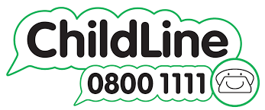
Childline is the UK’s free, 24-hour service for children and young people. Run by the NSPCC, Childline gives children and young people up to the age of 19 confidential support with whatever is worrying them.

CHILD SEXUAL EXPLOITATION (CSE)
Child sexual exploitation is a form of child sexual abuse. It occurs where an individual or group takes advantage of an imbalance of power to coerce, manipulate or deceive a child or young person under the age of 18 into sexual activity (a) in exchange for something the victim needs or wants, and/or (b) for the financial advantage or increased status of the perpetrator or facilitator. The victim may have been sexually exploited even if the sexual activity appears consensual. Child sexual exploitation does not always involve physical contact; it can also occur through the use of technology.

Types of CSE
  - Child on Child – exploitation of children and young people by other children and young people. This could happen through gangs, groups or individuals.
  - Older ‘boyfriend’
  - Sexual Bullying
  - Opportunistic – takes a situation where a young person or child is vulnerable and uses it to abuse the child/young person.
  - Familial – through someone that they know- a family member, a family friend or used as a debt repayment by a family member.
  - Online grooming which leads to sexual exploitation
  - Trafficked

Who is likely to be exploited?
CSE can happen to any young person. However, some children and young people may be more vulnerable and more susceptible to CSE.

Vulnerability Factors:
- Having a prior experience of neglect, physical and/or sexual abuse;
- Lack of a safe/stable home environment, now or in the past (domestic abuse or parental substance misuse, mental health issues or criminality, for example);
- Recent bereavement or loss;
- Social isolation or social difficulties;
- Economic vulnerability;
- Homelessness or insecure accommodation status;
- Connections with other children and young people who are being sexually exploited;
- Family members or other connections involved in adult sex work;
- Having a physical or learning disability;
- Being in care (particularly those in residential care and those with interrupted care histories); and
- Sexual identity.

Signs of CSE - Please see Appendix 3.6 for possible signs of CSE.

OTHER KEY SAFEGUARDING AREAS

- COUNTY LINES
County lines is a term used to describe gangs and organised criminal networks involved in exporting illegal drugs into one or more importing areas. Exploitation is an integral part of the county lines offending model with children and vulnerable adults exploited to move [and store] drugs and money. Children can easily become trapped by this type of exploitation as county lines gangs create drug debts and can threaten serious violence and kidnap towards victims.

EXTREMISM AND RADICALISATION
As part of the Counter Terrorism and Security Act 2015, schools have a duty to ‘prevent people being drawn into terrorism’. This has become known as the ‘Prevent Duty’. Staff should be alert to changes in children’s behaviour, which could indicate that they may be in need of help or protection. Staff should use their judgement in identifying children who might be at risk of radicalisation and act proportionately which may include the designated safeguarding lead (or deputy) making a Prevent referral.

-Definitions:
Terrorism is an action that endangers or causes serious violence to a person/people; causes serious damage to property; or seriously interferes or disrupts an electronic system. The use or threat must be designed to influence the government or to intimidate the public and is made for the purpose of advancing a political, religious or ideological cause.

Extremism is the vocal or active opposition to British fundamental values, including democracy, the rule of law, individual liberty and the mutual respect of those with different faiths and beliefs.
Radicalisation is the process by which a person comes to support terrorism and extremist ideologies associated with terrorist groups.
Our Policy on extremism and radicalisation is one of protecting children from harm by ensuring that they are taught in a way that promotes key values such as respect, tolerance and diversity. This is consistent with British values and is delivered through a broad and balanced curriculum, which promotes the spiritual, moral and cultural development of pupils and prepares them for the opportunities, responsibilities and experiences of life.

Terrorism (Terrorism Act 2006)
Forms of extremism leading to terrorism.
- Violence/property damage/endanger life/disrupt electronic systems
- Designed to influence government or intimidate the public
- Purpose to advance a political, religious, racial or ideological cause

Who is likely to be exploited?
Radicalisation or extremism can happen to any young person. However, some children and young people may be more vulnerable and more susceptible.

Vulnerability Factors
- Feelings of grievance and injustice
- Feeling under threat
- A need for identity, meaning and belonging
- A desire for status
- A desire for excitement and adventure
- A need to dominate and control others
- A desire for political or moral change
- Opportunistic involvement
- Family or friends’ involvement in extremism
- Being at a transitional time of life
- Being influenced or controlled by a group
- Relevant mental health issues
The school adapts the government’s ‘Prevent’ initiative and seeks to address any issues through four key areas as outlined in the Prevent Duty June 2015 (DFE):
  - Risk Assessment
  - Working in Partnership
  - Staff Training
  - ICT Policies

As a school we will endeavour to offer WRAP training (workshop to raise awareness of prevent) to all of our school staff.

CHILD CRIMINAL EXPLOITATION (CCE)
CCE is a form of abuse and occurs where an individual or group takes advantage of an imbalance in power to coerce, manipulate or deceive a child into criminal activity. The abuse can be perpetrated by individuals or groups, males or females, and children or adults. The abuse can be a one-off occurrence or a series of incidents over time, and range from opportunistic to complex organised abuse. Victims can be exploited even when activity appears consensual and it should be noted exploitation can be facilitated and/or take place online.

VIOLENCE AGAINST WOMEN & GIRLS (VAWG)
Violence Against Women and Girls comprises of Female Genital Mutilation (FGM), Honour Based Violence (HBV) and Forced Marriage (FM). The school recognises that incidents of Honour Based Violence (HBV) and Forced Marriage (FM) directly involving children at primary school may be scarce though not impossible. However, it is imperative that staff are aware of such issues that may affect families or involve families in our school and consequently the children at our school through older siblings or other family members.

HONOR BASED ABUSE (HBA)
So-called ‘honour-based’ abuse (HBA) encompasses crimes, which have been committed to protect or defend the honour of the family and/or the community, including Female Genital Mutilation (FGM), forced marriage, and practices such as breast ironing. All forms of so-called HBA are abuse (regardless of the motivation) and should be handled and escalated as such.
Where staff are concerned that a child might be at risk of HBA, they must contact the Designated Safeguarding Lead as a matter of urgency.

FORCED MARRIAGE (FM)
A Forced Marriage (FM) is a marriage conducted without the valid consent of one or both parties and where pressure is a factor. This is an entirely separate issue from arranged marriage. Forced Marriage is a human
rights abuse and falls within the Crown Prosecution Service definition of domestic violence. Young men and women can be at risk in affected ethnic groups. Whistleblowing may come from younger siblings. Forced Marriage is a criminal offence since June 2014.
Any information pertaining to Honour Based Violence or Forced Marriage must be reported to the Designated Safeguarding Leads who will contact the relevant agencies. Staff must not attempt to intervene directly in such cases. Issues around human rights are addressed through the curriculum focusing on key aspects such as rights of girls, individualism, and the British Values.

HUMAN TRAFFICKING
The school ensures that staff are familiar with the very real issue of human trafficking and how it could be affecting our families either directly or indirectly. We are aware that human trafficking is a violation of human rights and involves the forced trade of people. It is a crime and can involve the movement of people against their will within a country as well as between countries. The school is aware that our admissions procedures need to ensure that all papers are carefully checked and that any concerns should be followed up with the correct local safeguarding procedures. Particular attention should be given to children who present at school with “family members” other than their direct father and mother and to any child where the paper work of the adults is unclear.

BULLYING
Our policy on bullying is set out in our school Anti-Bullying Policy. We acknowledge that to allow or condone bullying may lead to consideration under child protection procedures.

RACIST INCIDENTS
Our policy on racist incidents is set out in our Anti-Racism Policy. It acknowledges that a single serious incident, repeated racist incidents or to allow or condone racism may lead to safeguarding procedures.

SHARING NUDES AND SEMI-NUDES (previously known as ‘sexting’)
In cases where nudes or semi-nudes have been shared, we follow guidance given to schools and colleges by the UK Council for Internet Safety (UKCIS): Sharing nudes and semi-nudes (December 2020)

Definition:
This advice uses the term ‘sharing nudes and semi-nudes’ to mean the sending or posting of nude or semi- nude images, videos or live streams by young people under the age of 18 online. This could be via social media, gaming platforms, chat apps or forums. It could also involve sharing between devices via services like Apple’s AirDrop, which works offline.

The term ‘nudes’ is used as it is most commonly recognised by young people and more appropriately covers all types of image sharing incidents.

By having in their possession, or distributing, indecent images of a person under 18 on to someone else – young people are not even aware that they are breaking the law, as these are offences under the Sexual Offences Act 2003. (CEOP, 2015) There are many different types of sexting and it is likely that no two cases will be the same. It is important we apply a consistent approach when dealing with an incident to help protect ourselves as staff the school and the pupil. The range of contributory factors in each case also needs to be considered in order to determine an appropriate and proportionate response. All staff should be familiar with this information.
School staff must also refer to the following documents for advice on responding to incidents involving Sexual violence, sexual harassment and sharing nudes and semi-nudes in schools:
    - Keeping Children Safe in Education 2023 – Part 5

In order for staff to understand schools’ powers of screening, searching and confiscating electronic devices that may contain indecent images or content we refer to the following guidance:
    - Searching, screening and confiscation- advice for schools 2022

LOOKED AFTER CHILDREN - (LAC)
The DSL is responsible for Looked After Children (LAC) and is the named Designated Teacher for LAC pupils alongside the DDSL. We keep a list of pupils who are looked after by the local authority. In the light of the research that shows that these pupils fare less well at schools than their peers and to narrow this gap, we monitor their progress and wellbeing carefully by:
  - Being involved in and following the guidance set out in the pupil’s personal education plan (PEP).
  - Designated Safeguarding Lead – oversees the general well-being and progress of all LAC children.
  - Offering in school support, such as the school counsellor.
  - Targeting pupil premium specifically to support children in care.
  - Attending any liaison or review meetings held on their behalf, including speaking for them or acting as their advocate at such meetings should they request it, and keeping in touch with social workers and/or carers.
  - Monitoring their attendance carefully and reporting any unexplained absence to social care and the Educational Welfare Officer.
  - Monitoring their academic progress carefully to try to ensure they are making good progress in school making full use of Target Tracker.
  - Informing their Year Team Leaders that they are on the looked after register without breaching confidentiality so he/she knows to register any concerns speedily to the safeguarding team
  - Looking out for difficulties with home learning or resources that may be a result of their being in care and liaising with carers to organise and manage their work and by providing the resources needed
  - Enlisting the support of and liaising with other agencies as appropriate
  - Checking that they have access to all elements of school life, including visits and other activities, and by giving these pupils the opportunities to take part in those self-esteem projects/residential organised by the school as and when appropriate.

SPECIAL GUARDIANSHIPS & ADOPTION
We keep a record of those pupils who are looked after by someone other than a parent, Adopted or on Special Guardianship plans. We offer them a support package (chosen from the above) appropriate to their particular circumstances.

PRIVATE FOSTERING
A private fostering arrangement is one that is made privately (without the involvement of a local authority) for the care of a child under the age of 16 years (under 18, if disabled) by someone other than a parent or close relative, in their own home, with the intention that it should last for 28 days or more.
A close family relative is defined as a ‘grandparent, brother, sister, uncle or aunt’ and includes half-siblings and step-parents; it does not include great-aunts or uncles, great grandparents or cousins.

Parents and private foster carers both have a legal duty to inform the relevant local authority at least six weeks before the arrangement is due to start; not to do so is a criminal offence. Whilst most privately fostered children are appropriately supported and looked after, they are a potentially vulnerable group who should be monitored by the local authority, particularly when the child has come from another country. In some cases privately fostered children are affected by abuse and neglect, or be involved in trafficking, child sexual exploitation or modern-day slavery.

We have a mandatory duty to report to the local authority where we are aware or suspect that a child is subject to a private fostering arrangement. School staff should notify the designated safeguarding lead when they become aware of private fostering arrangements. The designated safeguarding lead will speak to the family of the child involved to check that they are aware of their duty to inform the LA. The school itself has a duty to inform the local authority of the private fostering arrangements. On admission to the school, we will take steps to verify the relationship of the adults to the child who is being registered.

YOUNG CARERS
It is the responsibility of the Designated Safeguarding Lead to keep a record of those pupils who play the part of a major carer for a family member. However, such families do not often publicise their situation for
fear of social care involvement. We offer a support package to these pupils appropriate to their individual situation.

SERIOUS VIOLENCE
All staff receive training as part of their Safeguarding CPD programme on Youth Violence and Serious Violence. They are made aware of the indicators, which may signal children are at risk from, or are involved with serious violent crime. These may include increased absence from school, a change in friendships or relationships with older individuals or groups, a significant decline in performance, signs of self-harm or a significant change in wellbeing, or signs of assault or unexplained injuries. Unexplained gifts or new possessions could also indicate that children have been approached by, or are involved with; individuals associated with criminal networks or gangs and may be at risk of criminal exploitation. All staff should be aware of the range of risk factors which increase the likelihood of involvement in serious violence, such as being male, having been frequently absent or permanently excluded from school, having experienced child maltreatment and having been involved in offending, such as theft or robbery. Further advice for serious violence is provided in the Home Office’s Preventing youth violence and gang involvement and its Criminal exploitation of children and vulnerable adults: county lines.

PUPILS WITH SEND
The school is aware that pupils with Special Educational Needs and Disabilities (SEND) or certain health conditions can face additional safeguarding challenges. Children and young people with special educational needs and disabilities can face additional safeguarding challenges because:
- assumptions that indicators of possible abuse such as behaviour, mood and injury relate to the child’s condition without further exploration
- these children being more prone to peer group isolation or bullying (including prejudice-based bullying) than other children
- the potential for children with SEND or certain medical conditions being disproportionally impacted by behaviours such as bullying, without outwardly showing any signs
- communication barriers and difficulties in managing or reporting these challenges
The school seeks to ensure that all staff are aware of children’s needs and how to best support them. The staff are vigilant and work closely with parents, carers, guardians and other agencies to ensure these children are protected from harm.

SAFEGUARDING IN THE EARLY YEARS
The school has taken measures to ensure that children in the early years develop and thrive in a safe environment by:
- Ensuring that all staff adhere to Acceptable User’s policy for mobile phone and ICT equipment usage
- Ensuring that staff working in the early years are adequately trained
- Ensuring that at least one member of staff has paediatric first aid training and accompanies children on trips and visits.
- That all staff have up to date safeguarding training.
- Ensuring that the correct ratios of adults to children are applied at all times.

CONFIDENTIALITY
We recognise that all matters relating to Child Protection are of a confidential nature and should be treated as such.
- The Designated Safeguarding Leads and DSOs will disclose information about a pupil to the key member of staff on a need-to-know basis only. This information will only be passed on to relevant members of staff by the key member if and when it is required.
- All staff must be aware that they have a professional responsibility to share information with other agencies in order to safeguard children.
- All staff must be aware that they cannot and must not promise a child to keep a secret.

SUPPORTING STAFF
We recognise that staff working in the school who have become involved with a child who has suffered harm, or appears to be likely to suffer harm may find the situation stressful and upsetting. We will support such staff by providing an opportunity to talk through their anxieties with a safeguarding lead and to seek further support as appropriate. The Designated Safeguarding Leads act as each other’s supervision support. We advertise the following helpline for staff to contact should they need to access support out of hours from a trained professional.

https://www.educationsupportpartnership.org.uk/helping-you/telephone-support-counselling

ALLEGATIONS AGAINST STAFF and CONCERNS ABOUT STAFF BEHAVIOUR

Allegations or concerns about an adult working in the school whether as a teacher, supply teacher, other staff, volunteers or contractors
At Anson Primary School we recognise the possibility that adults working in the school may harm children, including governors, volunteers, supply teachers and agency staff. Any concerns about the conduct of other adults in the school should be taken to the head teacher immediately; any concerns about the head teacher should go to the Chair of Governors who can be contacted at: governors@anson.brent.sch.uk

Any concerns about the conduct of a member of staff, supply teachers, volunteers or contractors should be reported to the head teacher. The head teacher has to decide whether the concern is an allegation or low-level concern. The term ‘low-level’ concern does not mean that it is insignificant; it means that the behaviour towards a child does not meet the threshold for referral to the Local Authority Designated Officer (LADO).

LOW-LEVEL CONCERNS
Concerns may be graded Low-level if the concern does not meet the criteria for an allegation; and the person has acted in a way that is inconsistent with the staff code of conduct, including inappropriate conduct outside of work. Example behaviours include, but are not limited to:
- being over friendly with children;
- having favourites;
- taking photographs of children on their mobile phone;
- engaging with a child on a one-to-one basis in a secluded area or behind a closed door; or,
- using inappropriate sexualised, intimidating or offensive language.
If the concern has been raised via a third party, the head teacher will collect as much evidence as possible by speaking:
- directly to the person who raised the concern, unless it has been raised anonymously;
- to the individual involved and any witnesses.

Reports about supply staff and contractors will be notified to their employers, so any potential patterns of inappropriate behaviour can be identified.
We encourage staff to feel confident to self-refer, where, for example, they have found themselves in a situation, which could be misinterpreted, might appear compromising to others, and/or on reflection, they believe they have behaved in such a way that they consider falls below the expected professional standards.
Records will be kept confidential, held securely and comply with the Data Protection Act 2018. As a school, we will decide how long we retain this information, but it is recommended that it is kept on school file until the individual leaves their employment.
Records will be reviewed so that potential patterns of concerning, problematic or inappropriate behaviour can be identified.
If a concerning pattern of behaviour is identified and now meets the criteria for an allegation, then the matter will be referred to the LADO.
The records' review might identify that there are wider cultural issues within the school or college that enabled the behaviour to occur. This might mean that policies or processes have to be revised or extra training delivered to minimise the risk of it happening again.

WHISTLE BLOWING
We recognise that children cannot be expected to raise concerns in an environment where the staff fail to do so. All staff should be aware of their duty to raise concerns, where they exist, about the attitude or actions of colleagues. These concerns should be brought to the attention of the Head Teacher or Chair of Governors. Where there are concerns about the way that safeguarding is carried out in the school, staff should refer to the Whistle-blowing Policy.
A whistleblowing disclosure must be about something that affects the general public such as:
- a criminal offence has been committed, is being committed or is likely to be committed
- an legal obligation has been breached
- there has been a miscarriage of justice
- the health or safety of any individual has been endangered
- the environment has been damaged
- information about any of the above has been concealed.

The NSPCC runs a whistleblowing helpline on behalf of the government, the number is 0808 800 5000.

WHISTLE BLOWING PATHWAYS
If you have raised any concerns related to the safeguarding of pupils and you feel that, your concerns have not been adequately dealt with. You may wish to discuss your concerns with the one of the key people below.

Name | Role | Contact details
Mitchell Clarke | Chair of governors | governors@anson.brent.sch.uk
Florence Lindsay-Walters | Local safeguarding Designated  Officer (LADO) | Florence.lindsay-walters@brent.gov.uk
Family Front Door/MASH | To access social services | 0208 937 4300
NSPCC | Whistleblowing Helpline | 0800 028 0285

PHYSICAL INTERVENTION
We acknowledge that staff must only ever use physical intervention as a last resort and at all times be mindful to use minimal force necessary to prevent injury. We understand that physical intervention can cause injury or distress to a child. The school follows the statutory guidance on use of force published by the DfE.
https://www.gov.uk/government/publications/use-of-reasonable-force-in-schools

OUTSIDE AGENCIES – WORKING IN PARTNERSHIP
The school works very closely with outside agencies to support children and families. This includes health services, speech and language therapist, social care and the Educational Welfare Officer (EWO).

SAFER RECRUITMENT
  - The school is committed to safer recruitment and ensures that prospective employees or volunteers go through a thorough and rigorous process. All members of staff have DBS and this is updated every 4 years as agreed by governors.
  - The school holds a single Central Record with relevant data for all members of staff.
The following staff are trained in safer recruitment:
  - Head teacher - Simon Pile
  - Deputy head teacher - Justine Callaghan
  - Chair of Governors - Mitchell Clarke

In addition, we will ensure that the following checks are satisfactorily completed before a person takes up a position in the school:

  - Identity checks to establish that applicants are who they claim to be
  - Academic qualifications, to ensure that qualifications are genuine
  - Professional and character references prior to offering employment and interview process.
  - Satisfy conditions as to health and physical capacity
  - Previous employment history will be examined and any gaps accounted for

DISQUALIFICATION BY ASSOCIATION
A change in the law means that Disqualification by Association will only apply on domestic premises from September 2018. However, Disqualification under the Childcare Act 2006, still applies to staff themselves. Schools must no longer ask about the cautions or convictions of someone living or working in their household.

HEALTH AND SAFETY
Our Health & Safety policy and our Educational Visits Policy are set out in separate documents. They reflect the consideration we give to the protection of our children both within the school environment and when undertaking school trips and visits away from the school environment.

ACCIDENTS AND WELFARE
If a child is injured or an accident occurs, the incident is recorded on MedicalTracker and parents are informed via email. If the accident involves a head injury, parents will also be contacted by telephone. In the event of a serious accident, the headteacher will inform the local authority and a risk assessment will be carried out. The school welfare officer is first aid trained as well as a number of other adults in various classes in the school. Where a child requires medication regularly, a meeting is held with the welfare officer and parent/carer and a plan is set out, outlining the frequency of the medication and dosage. The parent also signs a letter to consent that the welfare officer can administer the medication.

INTIMATE CARE
Intimate care is any care which involves carrying out an invasive procedure (such as cleaning up a pupil after they have soiled themselves) to intimate personal areas. The school is committed to ensuring that all staff responsible for intimate care of children will undertake their duties in a professional manner at all times. Please see Intimate Care Policy for more details.

SITE SAFEGUARDING
The school safe guards the site in a variety of ways. All entrances to the school building are secure. Access to the school site is via the main office and all visitors are expected to sign in and wear a visitor’s badge. All members of the school have a fob that identifies them as staff. Regular checks are made by the site staff and appropriate risk assessments are made and distributed to staff so everyone is aware of their safeguarding duty. All risk assessments in relation to the school site are kept in the office.

FIRE DRILLS & CRITICAL INCIDENTS
All staff are made aware of the fire procedures for all buildings on site. This forms part of their new staff induction. Fire drills are carried out half termly and the findings are reported to the governors and actions are written and followed up by site staff. The staff and Board of Governors of Anson Primary are always conscious that an emergency, crisis or disaster affecting the school community could happen at any time, either in school, or a school trip or in the local community.

BEHAVIOUR of Visitors
The school expects all of the school community to adhere to the school’s core values. Any visitor who is causing harassment, anxiety and distress, the school will record such incidents and further action such as a ban from the school premises may be enforced. Such incidents are reported to the Governing Body under the private and confidential section of the Heads Report, which is distributed to Governors termly.

INFORMATION SHARING
Keeping Children Safe in Education 2023 paragraph 110 states that the Data Protection Act 2018 and UK GDPR do not prevent the sharing of information for the purposes of keeping children safe. Fears about sharing information must not be allowed to stand in the way of the need to safeguard and promote the welfare and protect the safety of children.

Appendix Contents

A1- Safeguarding Information Poster and Safeguarding Statement for visitors A2-Recognising abuse
A3 – Signs and Indicators of Abuse

A4 – Worry Box – Pupils reporting a concern or worry A5-The six R’s
A6-Reporting a concern flowchart A7 -Sexting – A Typology
A8-Safeguarding Concern Form A9-Body Map
A10-Transfer of Child Protection Records A11-File transfer record and receipt
A12-Welfare Notes Record Sheet A13-Welfare prompts
A14-Safeguarding Meeting Notes Record Sheet A15-Procedures for raising a concern
A16 – A guide for professionals and volunteers facing an allegation of abuse

A17 - Safeguarding and Child Protection Training Requirements
A18 – Flowchart for responding to incidents of Sexual Violence and Sexual Harassment A19 – Who to go to to report a concern

Appendix 1
School Safeguarding Statement for Visitors
Welcome to Anson Primary School. We recognise our moral and statutory duty to safeguarding our pupils and promote their welfare at all times. We endeavour to provide a safe and welcoming environment where children are respected and valued. We are alert to the signs of abuse and neglect and follow our procedures to ensure that children receive effective support, protection and justice. While working in our school we expect you to take care of our pupils and follow our procedures.
Keeping Children Safe
Safeguarding is everyone’s responsibility
If you are concerned about the safety of any child,
YOU MUST speak to . . .
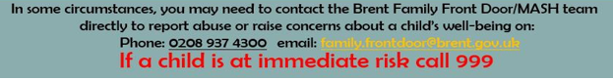
Do not question or try to secure evidence. Your responsibility is to report your concern, not to investigate. If a pupil tells you something that suggests they are at risk of harm, allow them to tell you as much as they wish and let them know that you must pass the information on to the DSL to keep everyone safe.
Justine Callaghan
Designated Safeguarding Lead
Elaine Barrett
Deputy Designated Safeguarding Lead
Simon Pile
Safeguarding Officer
Digital Safeguarding Lead



If you become concerned about a pupil’s immediate safety, notify the nearest member of staff and tell them why you are concerned. You should speak to the DSL or a member of the Safeguarding Team before you leave the school site. Ask a member of staff if you would like help to locate a member of the Safeguarding team. If you have any questions or wish to see our Safeguarding Policy please contact the DSL or see the school website. If you feel a child is at risk of immediate danger, call ‘999’

Appendix 2

Recognising Abuse
In the Children Acts 1989 and 2004, a child is anyone who has not yet reached their 18th birthday.

Safeguarding and promoting the welfare of children is defined in Working Together to Safeguard Children (2023) as:
- protecting children from maltreatment;
- preventing impairment of children’s health or development;
- ensuring that children are growing up in circumstances consistent with the provision of safe and effective care;
- taking action to enable all children to have the best outcomes
Abuse and neglect are forms of maltreatment of a child. Somebody may abuse or neglect a child by inflicting harm, or by failing to act to prevent harm. Children may be abused in a family or in an institutional or community setting, by those known to them or, more rarely, by a stranger for example, via the internet. They may be abused by an adult or adults, or another child or children.
The Children Act 1989 introduced the concept of significant harm as the threshold that justifies compulsory intervention in family life in the best interests of children, and gives local authorities a duty to make enquiries to decide whether they should take action to safeguard or promote the welfare of a child who is suffering, or likely to suffer, significant harm.

Appendix 3.1
WHAT SIGNS MAY A CHILD EXHIBIT IF THEY ARE A VICTIM OF ABUSE?

PHYSICAL ABUSE
DEFINITION:
A form of abuse which may involve hitting, shaking, throwing, poisoning, burning or scalding, drowning, suffocating or otherwise causing physical harm to a child. Physical harm may also be caused when a parent or carer fabricates the symptoms of, or deliberately induces, illness in a child.
SIGNS:
- Marks and Bruises
- Suspicious stories about how marks made
- Frequent bumps etc.
- Broken Bones
- Frightened / nervous at simple movements / jumpy
- Jumping when adult raises voice
- Introverted, shy or withdrawn
- Tearful
- Poor behaviour / Bullying others
- Repeating inappropriate behaviour/ bullying
- Violent outbursts
- Hair missing
- Scratches / burns
- Stories include violent descriptions / pictures depict regularly violent scenarios
- Hitting or aggressive to other children
- Sleeping in class
- Self-conscious when changing for PE
- Restless and fidgety
- Wetting / soiling them self
- Mood swings
- Little contact with other children
- Poor attendance
- Use of bad language
- Physically threatening behaviour
- Shouting

Appendix 3.2

FEMALE GENITAL MUTILATION (FGM) IS PHYSICAL ABUSE
DEFINITION:
FGM involves procedures that include the partial or total removal of the external female genital organs for cultural or other non-therapeutic reasons. The practice is medically unnecessary, extremely painful and has serious health consequences, both at the time when the mutilation is carried out and in later life. FGM is against the law except when performed by a registered medical profession on medical or mental health grounds. It is also illegal for someone to arrange for a child to go abroad with the intention of having her circumcised.
SIGNS
- Difficulty walking, sitting or standing
- Spending longer than normal in the bathroom or toilet due to difficulties urinating.
- Fracture or dislocation of legs/arms as a result of restraint
- Spend long periods of time away from a classroom during the day with bladder or menstrual problems
- Severe pain in groin area
- Haemorrhage
- Being withdrawn - emotional and psychological shock (exacerbated by having to reconcile being subjected to the trauma by loving parents, extended family and friends);
- Urinary infections
- Detached / isolated
- Change in physical appearance/dress & body language
- Withdrawn aggressive
- Unable to form relationships with adults
- Changes in attitude, personality or behaviour
- Changes in interaction with others
- Feelings shown through writing or art work
- Peer group problems
- Extremes of emotion
- Underachieving

Any suspicions of a child at risk of having or having had FGM must be reported immediately to the Designated Safeguarding Lead and the Head teacher. Girls aged 5 to 8 years are most risk but it
can happen at any age.

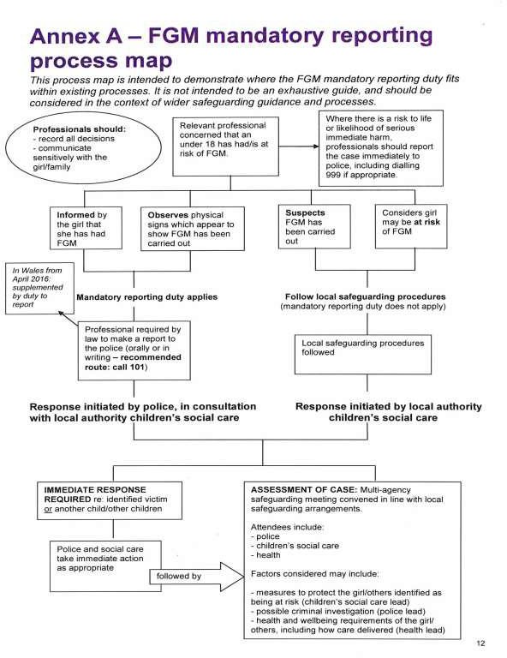

Appendix 3.3

EMOTIONAL ABUSE
DEFINITION:
The persistent emotional maltreatment of a child such as to cause severe and adverse effects on the child’s emotional development. It may involve conveying to a child that they are worthless or unloved, inadequate, or valued only insofar as they meet the needs of another person. It may include not giving the child opportunities to express their views, deliberately silencing them or ‘making fun’ of what they say or how they communicate. It may feature age or developmentally inappropriate expectations being imposed on children. These may include interactions that are beyond a child’s developmental capability as well as overprotection and limitation of exploration and learning, or preventing the child from participating in normal social interaction. It may 9 involve seeing or hearing the ill-treatment of another. It may involve serious bullying (including cyberbullying), causing children frequently to feel frightened or in danger, or the exploitation or corruption of children. Some level of emotional abuse is involved in all types of maltreatment of a child, although it may occur alone. Children witnessing domestic abuse between the parents or carers is also emotional abuse.
Signs include:
- Low self esteem
- Withdrawn / frightened / shy
- Secretive
- Makes little eye contact
- Emotionally finds it difficult to maintain relationships with peers and adults
- Jumpy or stuttering during conversations with adults
- Cries a lot / very sensitive
- A Loner
- Pictures use mainly dark colours
- Stealing
- Mood swings
- Lack of concentration
- Very quiet, speaks little
- Poor social skills
- Bullies others
- Very unsettled
- Anti-social behaviour
- Lack of confidence

Appendix 3.4

DOMESTIC ABUSE IS EMOTIONAL ABUSE
DEFINITION:
The cross-government definition of domestic violence and abuse is: any incident or pattern of incidents of controlling, coercive, threatening behaviour, violence or abuse between those aged 16 or over who are, or have been, intimate partners or family members regardless of gender or sexuality. The abuse can encompass, but is not limited to: psychological; physical; sexual; financial; and emotional.
Signs include:
- Disproportionate reactions ( overly apprehensive, tearful, angry or fearful)
- Withdrawn or quiet
- Negative relationships with opposite sex (children and peers)
- Aggression or bullying
- Tantrums
- Vandalism
- Problems in school, truancy,
- Difficulty with speech problems that were not there before
- Difficulties with learning
- Attention needing
- Struggle to make or keep friendships
- Reluctance to come to school
- Reluctance to go home with parents
- Aggressive comments or language (sometimes not expected for that age)
- Self-harming
- Nightmares or insomnia
- Bed-wetting
- Anxiety, depression, fear of abandonment
- Feelings of inferiority
- Constant colds, headaches, mouth ulcers, asthma, eczema
- Seem afraid or anxious to please
- Need for constant acceptance
- Be possessive over friends or belongings

Appendix 3.5

SEXUAL ABUSE
DEFINITION:
Involves forcing or enticing a child or young person to take part in sexual activities, not necessarily involving a high level of violence, whether or not the child is aware of what is happening. The activities may involve physical contact, including assault by penetration (for example rape or oral sex) or non-penetrative acts such as masturbation, kissing, rubbing and touching outside of clothing. They may also include non-contact activities, such as involving children in looking at, or in the production of, sexual images, watching sexual activities, encouraging children to behave in sexually inappropriate ways, or grooming a child in preparation for abuse. Sexual abuse can take place online, and technology can be used to facilitate offline abuse. Sexual abuse is not solely perpetrated by adult males. Women can also commit acts of sexual abuse, as can other
children. The sexual abuse of children by other children is a specific safeguarding issue in education.
Signs include:
- Hides under clothes / baggy clothes
- Inappropriate physical contact with other chn
- Withdrawn / shy
- Aggressive to chn of the opposite sex
- Scared of others
- Don’t like being touched
- Touch themselves or others
- Won’t change for PE
- Very quiet or loud
- Use of sexual language
- Stories or drawings include sexual connotations
- Exposing self
- Hesitate when wanting to talk to teacher
- Soiling/ wetting / stains on underwear
- Repeated Urine problems
- Re-enacting sexualised behaviour as part of play
- Bruising
- Sexually specific behaviour or / and language
- Abusive to other chn
- Little physical contact, finds hugs touches difficult will move away.

Appendix 3.6

CHILD SEXUAL EXPLOITATION (CSE) IS SEXUAL ABUSE
DEFINITION:
CSE occurs where an individual or group takes advantage of an imbalance of power to coerce, manipulate or deceive a child into sexual activity (a) in exchange for something the victim needs or wants, and/or (b) for the financial advantage or increased status of the perpetrator or facilitator. The victim may have been sexually exploited even if the sexual activity appears consensual. CSE does not always involve physical contact; it can also occur through the use of technology. CSE can affect any child or young person (male or female) under the age of 18 years, including 16 and 17 year olds who can legally consent to have sex. It can include both contact (penetrative and non-penetrative acts) and non-contact sexual activity and may occur without the child or young person’s immediate knowledge (e.g. through others copying videos or images they have created and posted on social media).
Signs include:
- Acquisition of money, clothes, mobile phones etc. without plausible explanation;
- Gang-association and/or isolation from peers/social networks;
- Exclusion or unexplained absences from school, college or work;
- Leaving home/care without explanation and persistently going missing or returning late;
- Excessive receipt of texts/phone calls;
- Returning home under the influence of drugs/alcohol;
- Inappropriate sexualised behaviour for age/sexually transmitted infections; • Evidence of/suspicions of physical or sexual assault;
- Relationships with controlling or significantly older individuals or groups;
- Multiple callers (unknown adults or peers);
- Frequenting areas known for sex work;
- Concerning use of internet or other social media;
- Increasing secretiveness around behaviours; and
- Self-harm or significant changes in emotional well-being.
- ​

Appendix 3.7

CHILD CRIMINAL EXPLOITATION (CCE) IS ABUSE
DEFINITION:
CCE is where an individual or group takes advantage of an imbalance of power to coerce, control, manipulate or deceive a child into any criminal activity (a) in exchange for something the victim needs or wants, and/or (b) for the financial or other advantage of the perpetrator or facilitator and/or (c) through violence or the threat of violence. The victim may have been criminally exploited even if the activity appears consensual. CCE does not always involve physical contact; it can also occur through the use of technology.
Signs include:
- children who appear with unexplained gifts or new possessions;
- children who associate with other young people involved in exploitation;
- children who suffer from changes in emotional well-being;
- children who misuse drugs and alcohol;
- children who go missing for periods of time or regularly come home late; and
- children who regularly miss school or education or do not take part in education

Appendix 3.8

NEGLECT
DEFINITION:
The persistent failure to meet a child’s basic physical and/or psychological needs, likely to result in the serious impairment of the child’s health or development. Neglect may occur during pregnancy, for example, as a result of maternal substance abuse. Once a child is born, neglect may involve a parent or carer failing to: provide adequate food, clothing and shelter (including exclusion from home or abandonment); protect a child from physical and emotional harm or danger; ensure adequate supervision (including the use of inadequate care-givers); or ensure access to appropriate medical care or treatment. It may also include neglect of, or unresponsiveness to, a child’s basic emotional needs.
Signs include:
- Child smells, clothes are dirty, hair un brushed
- Appears unhealthy but is always in school when unwell
- Low attendance – EWO involvement
- No Breakfast
- Is unfamiliar with basic routines of feeding self and toileting etc.
- Always hungry
- Late before and after school
- Attention seeking / needs praise to feel confident
- Poor hygiene, does not know how to use toilet properly
- Angry
- Parents have little contact with school. Do not attend parents evening
- Homework not completed / PE kit repeatedly forgotten
- Correct clothes not worn to school i.e. not warm enough in winter, not cool enough in summer
- Steal things
- Come to school on their own when they are too young
- Lying
- Older siblings care for younger chn and take on the parent role.
- Cries a lot
- Makes slow progress
- Packed lunch does not provide child with a balanced diet
- Over eats at lunchtime
- Untidy / unkempt
- Parents do not follow up medical requests form school i.e. need for eyes to be tested.
- Instability in family, different carers/ boyfriends
- Sleeps in class / Goes to sleep late little routine at home

Appendix 4 – Worry Box – reporting a concern or worry

Worry Boxes

Rationale
At Anson Primary School, it is our duty to keep our children safe. Whilst at school, children are encouraged to communicate their concerns or worries to a trusted adult. Some children may find it easier to express themselves in writing or through pictures. With this in mind, we have ‘Worry Boxes’ in classes.
Worry Boxes are containers, which children can post their thoughts and feelings in at any time they need to. By posting their worries, children are listened to and then given the opportunity to understand and resolve their problem or worry. We always encourage the children to speak out and stay safe but this gives pupils another way of communicating their needs in order to keep them safe.




name:_________________
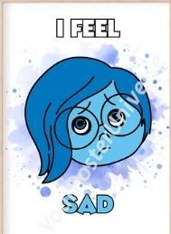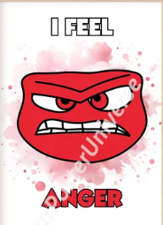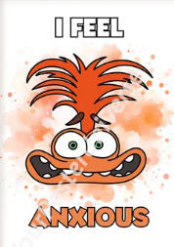
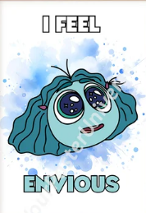

Appendix 5
Further Guidance for Staff to follow in dealing with child protection concerns/disclosures. Remember the 6Rs!
RECEIVE
- If a child wants to talk to you, never ask them to come back later. Ask them what they want to talk to you about and, if you are concerned about their welfare, give them the time to speak to you.
- Never promise confidentiality, inform the child that you are happy to talk to them but if they tell you anything that you believe may be putting them at harm that you will have to talk to someone.
- Listen carefully to the child. Do not stop a child who is freely recalling information.
- Where a child is visibly upset or has an obvious injury, it is good practice to ask a child why they are upset or how an injury was caused, or respond to a child wanting to talk to you to help clarify vague
concerns and result in the right action being taken.
REASSURE
- Ensure that the child is aware that they have done the right thing in talking to you and that they have not done anything wrong
- If you have any concerns that the child has been, or is at risk of harm, you must tell them that you will speak to someone to get help
REACT
- If you need to clarify information ask open-ended questions e.g.” Is there anything you'd like to tell me?", “Can you explain to me…” Can you describe to me….”
- Never ask leading or suggestive questions e.g. 'Did he/she do anything that they shouldn't have done?'
- Never ask 'accusing' questions e.g.” Why didn't you tell someone earlier?"
- Never criticise the alleged perpetrator, it may be someone that they will continue to live with.
- Never ask the pupil to repeat their disclosure for any other member of staff, it is your responsibility to share the information
- These four factors may compromise enquiries that need to be made later by children’s social care or Police.
RECORD
- Make notes as soon as possible afterwards using the words that the child has used.
- Do not record your assumptions and interpretations, just what you heard and saw.
- The recording must be a clear, precise, factual account completed on the Pupil Concern Sheet
- Complete a body map form to indicate the position of any bruising or other injury
- Do not destroy original notes even if you later write things up more neatly and fully.
- Record the date, time and place of the disclosure, and any noticeable non-verbal behavior using the safeguarding concerns form
- Sign any written records and identify your position in the school setting.
- Do not ask a child to write an account or sign any of your documentation as this may compromise enquiries that need to be made later
REFER
- Immediately inform the Designated Safeguarding Leader or in their absence a Designated Safeguarding Officer who will be responsible for following the appropriate procedures. In the absence of anyone
being available in school, contact the Local Authority
REFLECT
- Ask yourself if you have done everything you can within your role. Refer any remaining concerns to the DSL/O, e.g. any knowledge of siblings in the school, or previous contact with parents.
- Dealing with disclosures can be difficult and disturbing; you should seek support for yourself via the support within your school. The DSL Leader is available to support you.

Appendix 6
Are you ok? Ask for support or supervision if you need to.
Maintain confidentiality. Do not contact parents. The DSL will advise how parents will be contacted and who else needs to be informed of the incident.
If you have a suspicion but the pupil has not disclosed.
If a pupil discloses to you listen and reassure. Let the pupil know that you will need to pass on the information. Tell them what will happen next.
Notify the Designated Safeguarding Lead as soon as practicable.
Arrange medical help and inform medical staff that it is a child protection issue.
If you feel the child is at risk of harm find the Designated Safeguarding Lead immediately and report the concern. If the Designated Safeguarding team are unavailable find a member of the safeguarding team.
Reporting a concern flowchart
Notes:
If the Designated Safeguarding Lead is unavailable report the concern to the Deputy DSL or a member of the safeguarding team.
*See Poster.
Do not wait for evidence. You do not need proof of your concern.
Do not try to investigate.
Suspicion or disclosure that a pupil is at a risk of harm.
Is emergency medical treatment needed?
No
Yes

Complete a CPOMs record before the end of the day and alert a member of the Safeguarding Team.
Complete a CPOMs record before the end of the day and alert a member of the Safeguarding Team.

Appendix 7.1
Sharing Nudes and Semi-Nudes
Aggravated Incidents
YOUTH PRODUCED SEXUAL IMAGES
Reckless Misuse
Intent to harm
Youth Only
Adult involved
Romantic
Other
Sexual Attention seeking
Experimental Incidents

Aggravated incidents involve criminal or abusive elements beyond the creation, sending or possession of youth-produced sexual images
Adult offenders attempt to develop relationships by grooming teenagers, in criminal sex offences even without the added element of youth-produced images. Victims may be family friends, relatives community members or contacted via the Internet. The youth-produces sexual images may be solicited by adult offenders.
Youth Only: Intent to Harm cases that arise from interpersonal conflict such as break-ups and fights among friends; involve criminal or abusive conduct such as blackmail, threats or deception; or involve sexual abuse or exploitation by young people.
Youth Only: Reckless Misuse No intent to harm but images are taken or sent without the knowing or willing participant of the young person who is pictured. In these cases, pictures are taken or sent thoughtlessly or recklessly and a victim may have been harmed as a result.
Experimental incidents involve the creation and sending of youth-produced sexual images, with no adult involvement, no apparent intent to harm or reckless misuse.
Romantic episodes in which young people in ongoing relationships make images for themselves or each other, and images were not intended to be distributed beyond the pair.
Sexual Attention Seeking in which images are made and sent between or among young people who were not known to be romantic partners, or when one young person takes pictures and sends them to many others or posts them online.
Other cases that do not appear to have aggravating elements, like adult involvement, malicious motives or reckless misuse, but also do not fit into Romantic or Attention Seeking sub-types. These involve either young people who take pictures of themselves for themselves (no evidence of any sending or sharing intent to do so) or pre-adolescent (age 9 or younger) who did not appear to have sexual motives

Appendix 7.2

RESPONDING TO SHARING OF NUDES OR SEMI NUDES
Considerations – risk assessments
- Vulnerability of the child
- Coercion
- How shared and where
- Impact on children
- Age of children
- (For more information look at types of abuse and possible signs)
Risk assessment/Dealing with the incident Consider the risk of harm and at any point if there are ‘causes for concern’ you can refer back to police/social care. For more information refer back to the four types of abuse and the possible signs
Initial interview with safeguarding team
At this initial stage the safeguarding team review the information and consider the 5 points for immediate referral. They make an initial decision about whether the incident can be dealt with in house. Advice sought from safer schools officer.
Management in school ensure parents are informed and the incident is recorded following all child protection and safeguarding procedures.
Police/Social care/MASH referral
Refer to the MASH team – 0208 937 4300
– led by the DSL
Initial disclosure – This could come from a pupil directly, a parent, a pupil’s friend.
5 points for referral
- Adult involvement
- Coercion or blackmail
- Extreme or violent
- Under 13
- Immediate risk of harm

Appendix 8

Safeguarding Concern Form
(Only to be used in the event that CPOMS is unavailable)

Anson Primary School
Child Protection Record of Concern or Disclosure

Private & Confidential
Complete and pass on to Designated Safeguarding Lead or a member of the safeguarding team in their absence as soon as possible on the same day (this should be within an hour of disclosure). We will then investigate the matter and inform appropriate agencies. We will keep you informed of what is happening on a need to know basis.

Pupils Name: | Teacher:
Pupils Name: | DOB: | Class:
Concern identified by: |  | Date:
 |  | Time:
Nature of Concern (why are you concerned?) / Details of Disclosure (what have you observed/ been told)? Were there any other adults present who heard what was said?
Other relevant Information.

Signature of person completing the form
If you are not a member of the school staff please provides details of your school, agency or service together with a contact telephone number.
If the pupil has a visible injury, please indicate the location on the body map and staple the body map to this form.
Continue on reverse if needed
Passed to: Received by: Date:
Action taken by DSL / DDSL (other person receiving this form)
This form to be filed in pupils CP file

Signed:

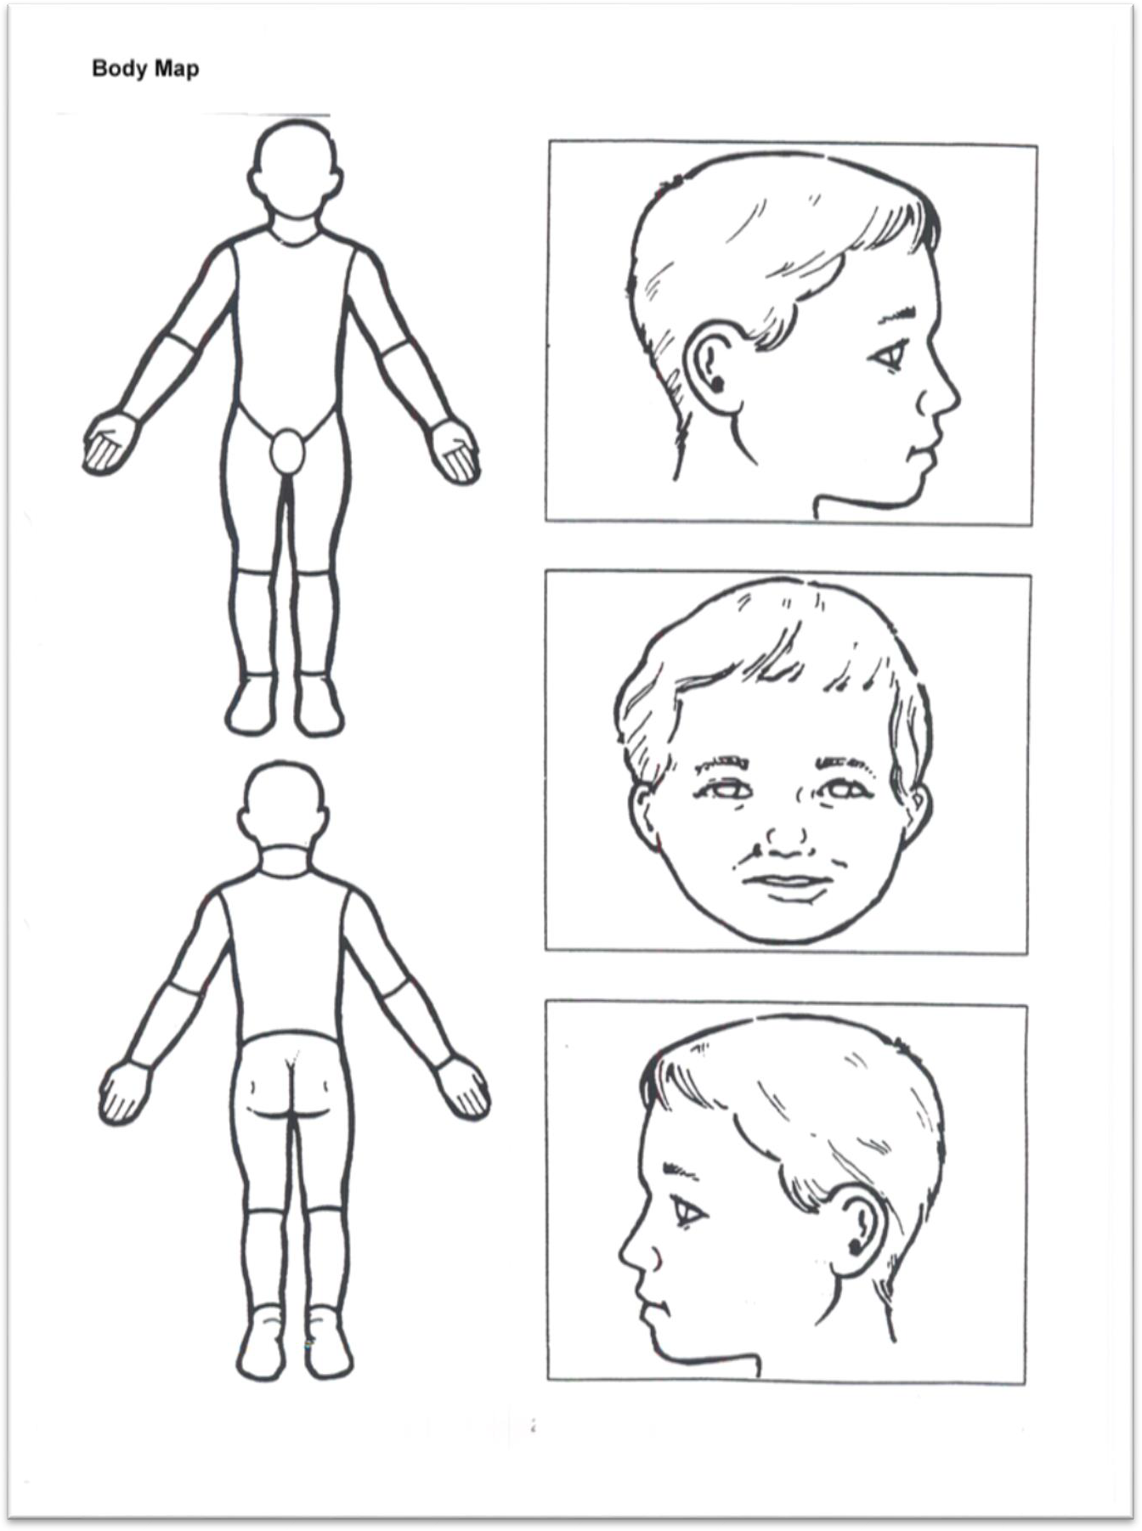

Appendix 10

Transfer of Child Protection Records

Keeping Children Safe in Education September 2023 states as part of the role of the designated safeguarding lead that they should:
Ensure their child protection file is transferred to the new school or college as soon as possible, and within 5 days for an in-year transfer or within the first 5 days of the start of a new term (when a new school is named, otherwise this may fall outside of 5 days). This should be transferred separately from the main pupil file, ensuring secure transit, and confirmation of receipt should be obtained. Receiving schools and colleges should ensure key staff such as designated safeguarding leads and SENCOs are aware as required. Lack of information about their circumstances can impact on the child’s safety, welfare and educational outcomes. In addition to the child protection file, the designated safeguarding lead should also consider if it would be appropriate to share any additional information with the new school in advance of a child leaving to help them put in place the right support. For example, information that would allow the new school to continue supporting children who have had a social worker or been victims of abuse.

There is a joint responsibility when a child starts at a new school to ensure the receiving school has all existing child protection records. When a school admits a new pupil, they must always check with the previous school whether there are any child protection records to transfer. However, it is also the responsibility of the original school to ensure any records are transferred to the new school.

Appendix 11
FILE TRANSFER RECORD AND RECEIPT

PART 1: To be completed by sending / transferring school or college

NAME OF CHILD:
DOB:
NAME OF SCHOOL
SENDING CP FILE:
ADDRESS OF SCHOOL SENDING CP FILE:
METHOD OF  DELIVERY: | BY HAND SECURE POST ELECTRONICALLY
DATE FILE SENT:
NAME OF DSL TRANSFERRING FILE:
NAME OF PERSON
TRANFERRING TO:
SIGNATURE:

PART 2: To be completed by receiving school or college

NAME OF SCHOOL
RECEIVING FILE:
ADDRESS OF SCHOOL RECEIVING FILE:
DATE RECEIVED:
NAME OF PERSON RECEIVING FILE:
DATE CONFIRMATION
OF RECEIPT SENT:
SIGNATURE:

Receiving School: Please complete Part 2 and return this form to the Designated Safeguarding Lead listed in Part 1 above. You are advised to keep a copy for your own reference.

Appendix 12

Anson Primary School - Welfare Notes

Date: | Welfare Check Required by:
Regarding (Child / Purpose): | Attendance: (as of today)
 | Present:
Completed by: | Possible sessions:
 | Authorise absence:
 | Unauthorised absence:
Date of Birth: | Unexplained absence:
 | Late before reg closed:
Date of Admission:
Notes:
Behaviour and attitude: Social interaction: Academic:
SEND:
Presentation: Parental engagement: General Comments:
Actions:
Please refer to prompts below to support with writing of Welfare Notes

Appendix 13
Welfare prompts

Attendance:
(What is the child/ren’s attendance in the current / last term? If attendance is low, are there justifiable reasons for this?)

Punctuality:
(If the child/ren is frequently late in arriving or being collected, what are the reasons given by the parent/s?)

Presentation:
Does the child/ren wear the clean, neat, weather appropriate and full school uniform? Does the child/ren take pride in his/her presentation?
Special needs:
Academic performance:
Behaviour at school:
Social interaction: (please describe the child/ren’s interaction with peers as well as adults)

Parental involvement:
Who brings the child/ren to and from school?
Do the parents meet with the child/ren’s teachers as and when necessary?
Describe the child/ren’s interaction with the parent / how does the child/ren talk about their parent at school?
Please describe any strengths and / or concerns noted about parenting for the child/ren
If the school is aware of any issues with regards to the child/ren’s parent/s i.e. domestic violence, mental health concerns, drugs or alcohol misuse, etc. then please give details of the same.
Are you aware of any other adult residing at this address? If so, please give details of information regarding this adult that may impact on the child (ren).

Appendix 14

Anson Primary School Safeguarding Meeting Notes

Date: | Present at meeting:
Regarding (Child / Purpose): | Person Taking Notes:
Notes:
Actions:

Appendix 15
Procedures for raising a concern
Our school procedures for safeguarding children will be in line with Local Authority and Brent Safeguarding Partnership procedures and in conjunction with Keeping Children Safe in Education September 2023.

You have a concern about a child / young person’s wellbeing, based on:
  - Something the child / young person / parent has told you
  - Something you have noticed about the child’s behaviour, health, or appearance
  - Something another professional said or did
Even if you think your concern is minor, the DSL may have more information that, together with what you know, represents a more serious worry about a child.
It is never your decision alone how to respond to concerns – but it is always your responsibility to share concerns, no matter how small.

- Decide whether you need to find out more by asking the child / young person, or their parent to clarify your concerns, being careful to use open questions.
- Let the child/young person know what you plan to do next if you have heard a disclosure of abuse or you are talking with them about your concerns. Do not promise to keep what s/he tells you a secret.
…for example, ‘I am worried about your bruise and I need to tell Miss Callaghan so that she can help us think about how to keep you safe’

- Inform the DSL immediately. If the DSL is not available, inform their Deputy. If neither are available, speak to a member of the Safeguarding Team. If there is no other member of staff available, you must make the referral yourself using the Brent Family Front Door referral contact.

- Make a CPOMs record or a written record in the event that access to CPOMs cannot be gained as soon as possible after the event, noting:
  - Name of child
  - Date, time and place
  - Who else was present
  - What was said/What happened/What you noticed
… speech, behaviour, mood, drawings, games or appearance
  - If the child or the parent raised the concern or made the disclosure, record their words rather than your interpretation
  - Analysis of what you observed & why it is a cause for concern
- The DSL may take advice from Brent Family Front Door (BFFD)

- The DSL makes the referral to the BFFD
The referral will note all previous intervention by the school with the child, any relevant history relating to the child, their siblings or the family.
- The DSL shares information with other relevant professionals, recording reasons for sharing information and ensuring that they are aware of what action the other professionals will take as a

result of information shared.
- The DSL informs parent that they have made a CP referral if safe, if the parent does not already know, and if there is no reason not to let them know.

BFFD may suggest to delay informing the parent in cases of suspected sexual abuse, or where informing the parent might put the child at further risk, to prevent the child being harmed or intimidated (and retracting their disclosure) or in cases of suspected Fabricated or Induced Illness by proxy, the parent is not informed that this is being considered.
- The DSL/DDSL remains in close communication with other professionals around the child/young person and with the family, in order to share any updates about the child / young person

If a child protection investigation is pursued, the DSL and other key school staff will:
- Work closely and collaboratively with all professionals involved in the investigation, to keep the child / young person safe
- Attend a child protection conference when invited and provide updated information about the child
- Attend any subsequent child protection review conferences.
- Attend core group meetings and take an active role in the implementation of the protection plan.
REMEMBER YOU HAVE A STATUTORY DUTY UNDER THE EDUCATION ACT 2011 TO PASS ON ANY CHILD PROTECTION CONCERNS ABOUT A CHILD

Appendix 16
https://media.inzu.net/f9e1fab6a6c10d044839fb1bee0a4704/mysite/articles/468/7_AAPPamphlet2015.pdf

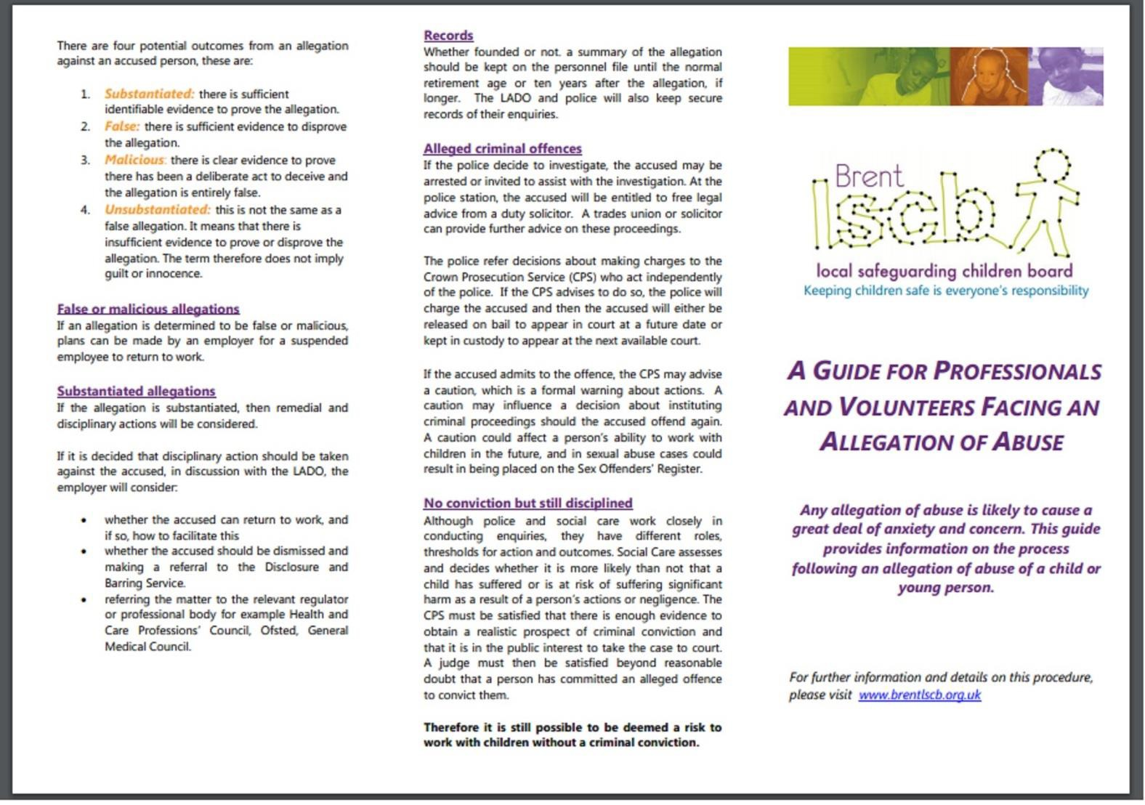

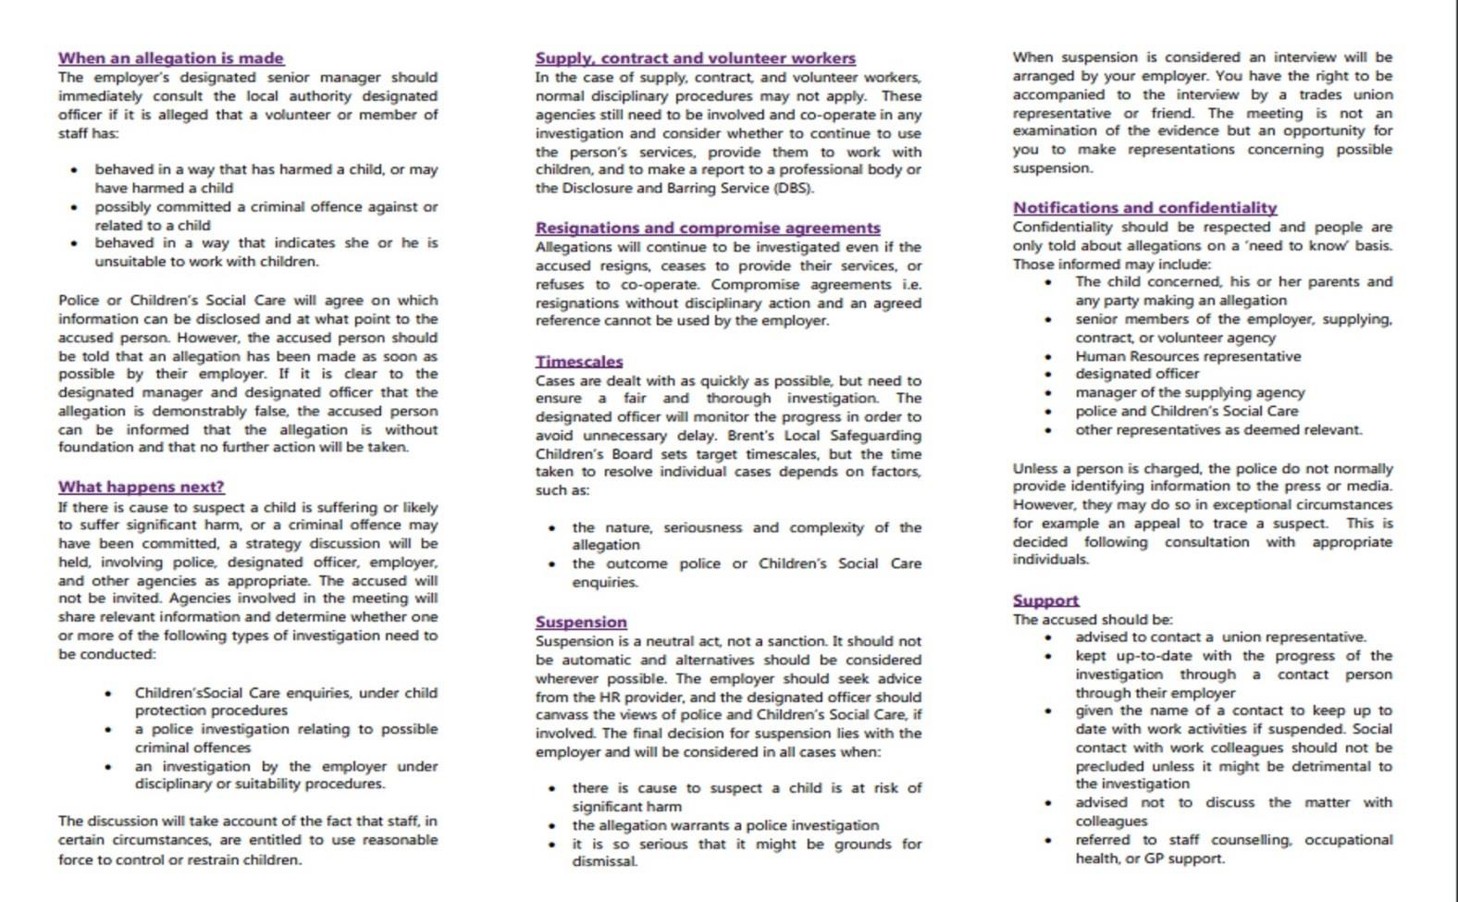

Appendix 17 – Staff Development in Safeguarding and Child Protection

Staff Development in Safeguarding and Child Protection
Keeping Children Safe in Education (DfE 2024)
Safeguarding training for staff, including online safety training, should be integrated, aligned and considered as part of the whole school or college safeguarding approach and wider staff training and curriculum planning.
Know that safeguarding and promoting the welfare of children is everyone’s
responsibility.
Know that that professionals should always consider what is in the best interests of the
child.
Know that everyone who comes into contact with them has a role to play in identifying concerns, sharing information and taking prompt action
Know the definition of safeguarding and promoting the welfare of children
Know that children refers to everyone under the age of 18.
Know that all school and college staff have a responsibility to provide a safe environment
in which children can learn.
Know that all schools and colleges should have a designated safeguarding lead who will provide support to staff members to carry out their safeguarding duties
Know that all school and college staff should be prepared to identify children who may
benefit from early help
Know that in the first instance, staff should discuss early help requirements with the
designated safeguarding lead.
Know that all staff may be required to support social workers and other agencies
following any referral
Know that all teachers, including head teachers, should safeguard children’s wellbeing and maintain public trust in the teaching profession
Be aware of the contents of the school's safeguarding and child protection policy
Be aware of the contents of the school's staff code of conduct
Be aware of the role of the designated safeguarding lead
All staff members should be aware that they must take part in safeguarding and child protection training which is regularly updated, at least annually
All staff should be aware of the early help process, and understand their role in it.
All staff should be aware of the process for making referrals to children’s social care and for statutory assessments under the Children Act 1989
All staff should know what to do if a child tells them he/she is being abused or neglected
All staff should know how to manage the requirement to maintain an appropriate level
of confidentiality
All staff must know that they should never promise a child that they will not tell anyone
about an allegation

All staff should understand the definition of abuse
All staff should understand the signs and symptoms of physical abuse
All staff should understand the signs and symptoms of emotional abuse
All staff should understand the signs and symptoms of sexual abuse
All staff should understand the signs and symptoms of neglect
All staff should understand the impact and indicators of child sexual exploitation (CSE)
All staff should be aware of the impact of drug taking
All staff should be aware of the impact of alcohol abuse
All staff should be aware that technology is a significant component in many
safeguarding and wellbeing issues.
All staff should be aware of the dangers of sharing nude and semi-nude images, including videos
It is important that all staff recognise the indicators and signs of child on child abuse and know how to identify it and respond to reports.
All staff should understand, that even if there are no reports in their schools or colleges it does not mean child-on-child abuse is not happening, it may be the case that it is just not being reported.
It is essential that all staff understand the importance of challenging inappropriate behaviours between peers, many of which are listed below, that are actually abusive in nature.
Staff should be able to recognise the signs of child-on-child abuse and how to report their concerns. (The Ofsted Framework (2022) says that inspectors will check 'that the school’s staff have appropriate knowledge of Part 5 [Child on child sexual violence and
sexual harassment] of the government’s ‘Keeping children safe in education’ guidance.')
All staff should be able to reassure victims [of child-on-child sexual abuse] that they are being taken seriously and that they will be supported and kept safe.
All staff should be aware of the dangers of children going missing from school, home or
care
Staff should be aware of the definition of domestic abuse. (Note: The definition of Domestic Abuse Act 2021 (Part 1) applies to children if they see or hear, or experience
the effects of, the abuse; and they are related to the abusive person. Children are victims of domestic abuse.)
All staff should be aware of the impact of domestic abuse
All staff should be aware of fabricated or induced illness
All staff should have an awareness of faith abuse
All staff should consider whether children are at risk of abuse or exploitation in situations outside their families. [This is known as Extra-familial harm or sometimes Contextual Safeguarding]
All staff should be aware of impact of the court system
All staff should be aware of impact of family members in prison
All staff should be aware of the impact of 'County Lines'
All staff should be aware of the impact of child criminal exploitation (CCE)

All staff should be aware of homelessness
All staff should be aware of female genital mutilation (FGM)
All teachers should be aware of their duty to report a disclosure of FGM to the police
All staff should have an awareness of forced marriage
All staff should be aware of the indicators, which may signal children are at risk from, or are involved with serious violent crime.
All staff should be aware of the impact of gangs and youth violence
All should have an understanding of so-called 'Honour-based Abuse'
All staff should have an awareness of gender-based violence against women and its
difference forms
All staff should have an awareness of hate crime
All staff should be aware of the impact of poor mental health on safeguarding
All staff should be aware that mental health problems can, in some cases, be an indicator that a child has suffered or is at risk of suffering abuse, neglect or exploitation.
All staff should have an awareness of private fostering and the duty on schools to report
such arrangements
All staff should have an awareness of relationship abuse
All staff should have an awareness of trafficking and modern day slavery
All staff should understand the school's duty to prevent radicalisation
All staff should understand the signs to looking for when considering the risk of
radicalisation
All staff should know that if a child is in immediate danger, or at risk of harm a referral should be made to children's social care or the police
All staff should know that all concerns, discussions and decisions should be made in
writing
All staff should aware of the impact of poor safeguarding practice
All staff should understand the school's whistleblowing policy
All staff should be aware of how to raise a concern outside the school or college
All staff should know that they are able to make a referral to children's social care themselves
All staff should understand the impact of technology on safeguarding
All staff working with under-8s, should understand what is meant by 'Disqualification by
Association'
All staff should understand the definition of 'upskirting'
All staff should be aware of meaning of 'Position of Trust' in the Sexual Offences Act 2003

All staff should be aware that untrained staff should not make a diagnosis, but can make
observations
All staff should be aware that traumatic experiences can have a life-long impact on
mental health, behaviour and education
All staff should be aware that when a child has a social worker, it is an indicator that the
child is more at risk than most pupils.
Schools and colleges should ensure that staff understand how to recognise and report concerns about other adults in the school, including low-level concerns policy by ensuring their staff are clear about what appropriate behaviour is, and are confident in distinguishing expected and appropriate behaviour from concerning, problematic or inappropriate behaviour, in themselves and others.
What to do if your worried a child is being abused (DfE 2015)
All staff should understand that children with special educational needs or disabilities are
more vulnerable to abuse and harm
All staff should be aware of the indicators of abuse or neglect traumatic experiences can have a life-long impact on mental health, behaviour and education
Guidance for safer working practices (Safer Recruitment Consortium 2022)
All staff should understand how to work with children so that they protect children from
harm
All staff should understand how to work with children in an open and transparent way
All staff should understand how to behave in a professional way.
Prevent Duty (DfE 2015)
All staff should understand what the Prevent duty means for schools
All staff should understand what to do to demonstrate compliance with the duty
All staff should understand where to find further information, advice and support
All staff should be able to identify children who may be vulnerable to radicalisation, and know what to do when they are identified
All staff should understand the school's arrangements to promote pupils’ welfare and prevent radicalisation and extremism
All staff should be able to identify children who may be vulnerable to radicalisation, and know what to do when they are identified
All staff should be able to demonstrate a general understanding of the risks affecting
children and young people in the area
All staff should be able to demonstrate a specific understanding of how to identify individual children who may be at risk of radicalisation
All staff should understand the online risks of radicalisation
All staff should understand how to refer concerns to the school's designated
safeguarding lead
All school staff should understand when it is appropriate to make a referral to the Channel programme

Child Sexual Exploitation - definition and guide for Practioners (DfE 2017)
All staff should be aware of the guidance set out in section A of 'Child Sexual Exploitation'
(DfE 2017)
All staff should understand the definition of child sexual exploitation
All staff should understand which children are especially vulnerable to sexual
exploitation
All staff should understand how sexual exploitation can have links to other kinds of crime
All staff should understand the possible indicators of child sexual exploitation
School procedures
All staff should know how to report concerns about a child
All staff should know how to report allegations about an adult that may meet the harm threshold
All staff should know how to report concerns or allegations about an adult that do not meet the harm threshold (so-called 'low level concerns')
All staff should know how to report concerns about the head teacher
All staff should know how to report concerns about the proprietor (where relevant)
A Competency Framework for Governance (DfE 2017)
Someone on the Board knows the requirements relating to the safeguarding of children
Everyone on the Board knows the duties relating to safeguarding, including the Prevent Duty
Sexual Violence and Sexual Harassment between children (DfE 2021)
All staff should understand issues around sexual violence and sexual harassment
between children
All staff should understand the school's approach to managing incidents of sexual
violence and sexual harassment
All staff should be aware that safeguarding incidents and/or behaviours can be associated with factors outside the school or college and/or can occur between children outside of these environments.
Teaching online safety in schools (DfE, 2019)
All staff should be aware of the risks and dangers associated with online devices and the
internet.
School Inspection Handbook for September 2023 (Ofsted)
Inspectors will check…'that the school’s staff have appropriate knowledge of Part 5 [Child on child sexual violence and sexual harassment] of the government’s ‘Keeping children safe in education’ guidance.'

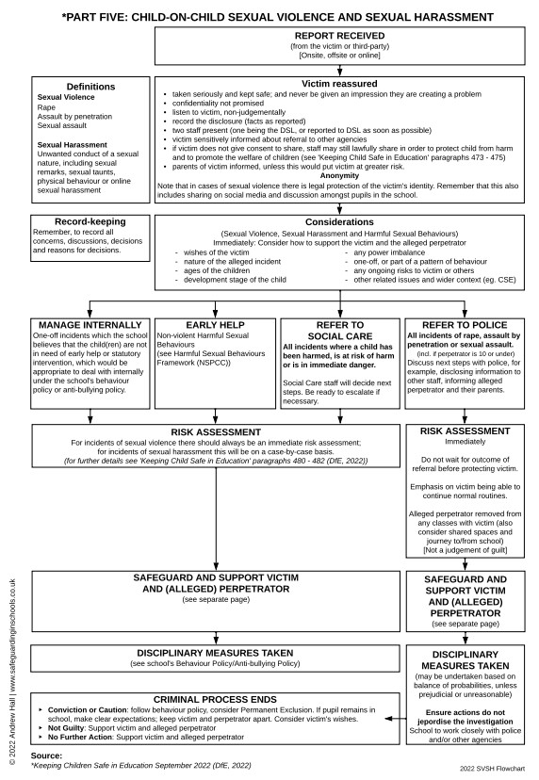
Appendix 18 – Flowchart for responding to incidents of Sexual Violence and Sexual Harassment

Appendix 19 – Who do I go to, to report a concern?



