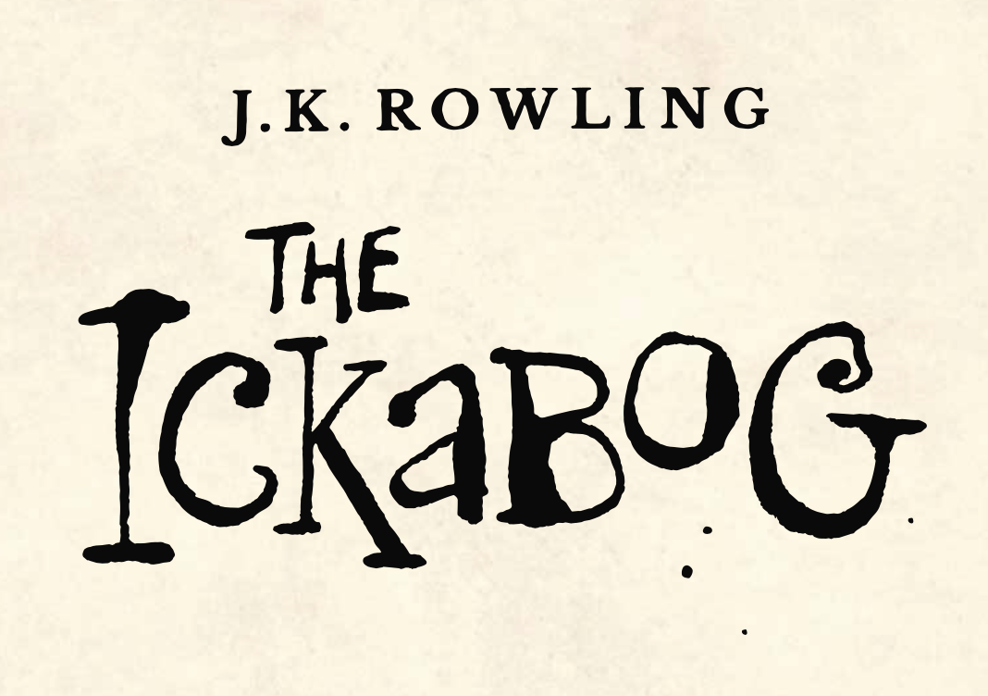

In Chapter One we learn a lot about the country of Cornucopia. We read about Chouxville, Kurdsburg, Baronstown, Jeroboam and the Marshlands.

Can you use the information in the text to create a map of Cornucopia?

“The capital of Cornucopia, Chouxville, lay in the south of the country, and was surrounded by acres of orchards, fields of shimmering golden wheat, and emerald-green grass, on which pure white dairy cows grazed.”

“To the north of Chouxville lay more green fields and clear, sparkling rivers, where jet-black cows and happy pink pigs were raised. These in turn served the twin cities of Kurdsburg and Baronstown, which were separated from each other by an arching stone bridge over the main river of Cornucopia, the Fluma, where brightly coloured barges bore goods from one end of the kingdom to another.”

“A few hours north of Kurdsburg and Baronstown, you came upon acres of vineyards bearing grapes as large as eggs, each of them ripe and sweet and juicy. Journey onwards for the rest of the day and you reached the granite city of Jeroboam, famous for its wines.”

“But a little north of Jeroboam, a strange thing happened. It was as though the magically rich land of Cornucopia had exhausted itself by producing the best grass, the best fruit, and the best wheat in the world. Right at the northern tip came the place known as the Marshlands, and the only things that grew there were some tasteless, rubbery mushrooms and thin dry grass, only good enough to feed a few mangy sheep.”